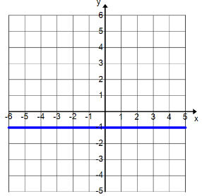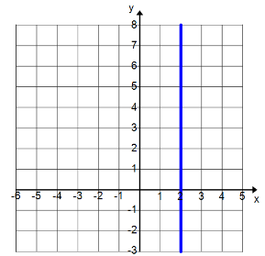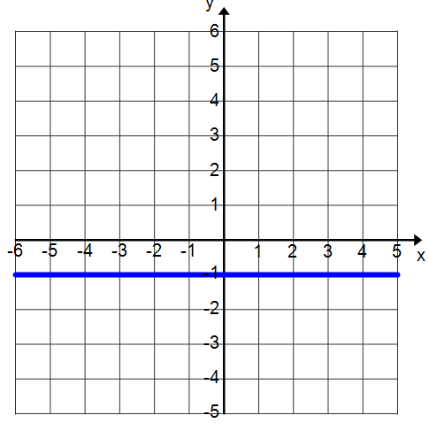

|  |  |  |
| --- | --- | --- |
| Table | Graph | Verbal Description |
|  |  | The **total cost** of renting a banquet hall **is a** **function of** the **number of hours** the hall is rented. The owner of the banquet hall charges $85 per half hour up to a maximum of 4 hours plus a $50 cleaning fee. What is the rate of change of the total cost with respect to the number of hours? |
|  |  | |  | | --- | | A college student is moving into a campus dormitory. The student rents a moving truck for $19.95 plus .99 every mile. | |
|  |  | Senior class charged $3 to wash a car and $5 to wash a pick-up truck or a sport utility vehicle. They earned a total of $30. Write the equation that describes the scenario. |
|  |  | ***Reviewing Arithmetic Sequences:*** Zelle has knitted 61 rows of a scarf. Each day she adds 17 more rows. *(61 is not the y-intercept)* |

Name ________________________________________ Period ____ Date ____/___/ ____

**Writing Linear Equations**