Name:____________________________________________Date:________________________Period:_________
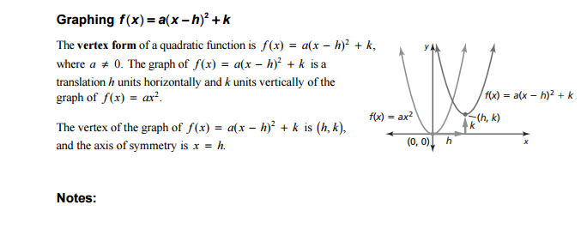

For problems 1 – 4, identify the vertex of the given function.
- $f\left(x\right)=5(x-4)^{2}+5$ 2. $f\left(x\right)=(x+3)^{2}+6$

- $f\left(x\right)=3({x-8)}^{2}-4$ 4. $f\left(x\right)= {(x+2)}^{2}-5$

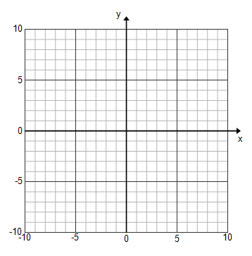
For problems 5-6, graph the given function and identify the vertex.
- $f\left(x\right)=3{(x-3)}^{2}+5$ 6. $f\left(x\right)= {(x+4)}^{2}-2$

For problems 7 – 8, graph the given function, identify the vertex
and write the axis of symmetry.
- $f\left(x\right)= {(x-3)}^{2}+2$ 8. $f\left(x\right)={\frac{1}{2}(x-4)}^{2}-1$

