Standard Form: $f\left(x\right)=ax^{2}+bx+c$
Vertex Form: $f(x)=a{\left(x-h\right)}^{2}+k$
Intercept Form: $f\left(x\right)=a(x-p)(x-q)$

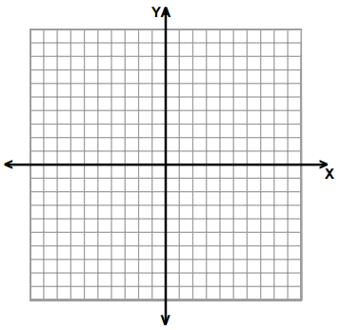
Find the quadratic function with the given information. Write the function in standard, vertex and intercept form. Use the graph or table to find a third point on the parabola. State the domain and range.
1. Vertex $(2, 0)$ passing through $(1, 3)$

Vertex Form: ______________________________

Standard Form: ____________________________

Intercept Form: ____________________________

Domain: ________________ Range:____________________

x | f(x)
2. Vertex$(-3, 0)$ and $f\left(-5\right)= -4$

Vertex Form: ______________________________

Standard Form: ____________________________

Intercept Form: ____________________________

Input: ________________ Output:____________________

3. $f\left(1\right)= 7$ and $f\left(3\right)=7$ with a minimum of (2,5)

Vertex Form: ______________________________

Standard Form: ____________________________

Intercept Form: ____________________________

Independent: _____________ Dependent:_________________

x | f(x)

4. Vertex $(0, 0)$ and $f\left(-2\right)= 8$

Vertex Form: ______________________________

Standard Form: ____________________________

Intercept Form: ____________________________

Domain: ________________ Range:____________________

5. Zeros at $\left(5, 0\right)$ and $(1,0)$and $f\left(0\right)= 1$

Vertex Form: ______________________________

Standard Form: ____________________________

Intercept Form: ____________________________

Input: ________________ Output:____________________

x | f(x)
6. Vertex $(4, 8)$ and passes through the origin

Vertex Form: ______________________________

Standard Form: ____________________________

Intercept Form: ____________________________

Independent: ___________ Dependent:______________

7. The maximum value of $g$ is $g\left(-1\right)=6$ and another point is $g\left(-3\right)=4$

Vertex Form: ______________________________

Standard Form: ____________________________

Intercept Form: ____________________________

Input: ________________ Output:____________________

x | f(x)
8. Zeros at $\left(5, 0\right)$ and $(1,0)$and $f\left(0\right)= 1$

Vertex Form: ______________________________

Standard Form: ____________________________

Intercept Form: ____________________________

Input: ________________ Output:____________________

9. Intercepts at $\left(-1,0\right)$ and $(5,0)$and $(0,15)$

Vertex Form: ______________________________

Standard Form: ____________________________

Intercept Form: ____________________________

Independent: ________________ Dependent:____________________

x | f(x)
10. Solutions at at $\left(2, 0\right)$ and $(-1,0)$and y-intercept at $(0,6)$

Vertex Form: ______________________________

Standard Form: ____________________________

Intercept Form: ____________________________

Input: ________________ Output:____________________

11. Maximum at $\left(-2,9\right)$ and y-intercept at $-3$

Vertex Form: ______________________________

Standard Form: ____________________________

Intercept Form: ____________________________

Domain: ________________ Range:____________________
Name:_______________________________________
Date:_________________________ Period:_________

Exit Ticket
Complete and turn in before the end of class.
Find the quadratic function with the given vertex and point. Write the function in standard, vertex and intercept form. Use the graph to find a third point on the parabola. State the domain and range.

- The function has a vertex at (-1, 9) and f(-4) = 0.

Standard Form:______________________

Vertex Form:________________________

Intercept Form:______________________

Domain:__________________________ Range:_____________________________
x
f(x)

