Write the new function and determine the steepness.  $1. f\left(x\right)=2x+3$  $$g\left(x\right)=f\left(x\right)+2=___________________$$  $= ___________________$  g(x) translates: Up Down Left Right  g(x): Steeper Less Steep Same Steepness  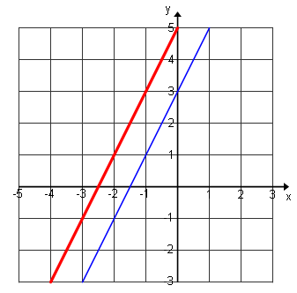  $$g(x)$$  $$f(x)$$ | Write the new function and determine the steepness.  $3. f\left(x\right)=2x+3$  $$g(x)=2f(x)=_______________$$  $= _______________$  g(x) translates: Up Down Left Right  g(x): Steeper Less Steep Same Steepness  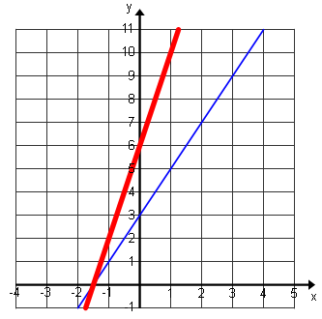  $$g(x)$$  $$f(x)$$
Write the new function and determine the steepness.  $2. f\left(x\right)=2x+3$  $$g\left(x\right)=f\left(x\right)-2=__________________$$  $= __________________$  g(x) translates: Up Down Left Right  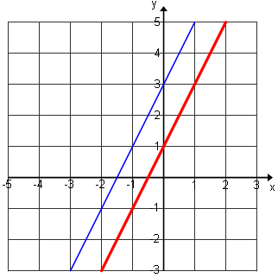  g(x): Steeper Less Steep Same Steepness  $$f(x)$$  $$g(x)$$ | Write the new function and determine the steepness.  $4. f\left(x\right)=2x+3$  $$g(x)=\frac{1}{3}f(x)=___________________$$  $= ___________________$  g(x) translates: Up Down Left Right  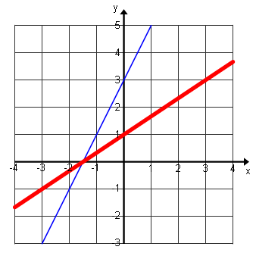  g(x): Steeper Less Steep Same Steepness  $$f(x)$$  reflection  $$g(x)$$
Reflection:
Name ___________________________________________________ Date ___/___/____ Period ____
Transformations From Other Functions
$F\left(x\right)+ d means: af(x) means:$

Write the new function and determine the steepness.  - $f\left(x\right)=2x+6$  $$g(x)=f(x-4)=_______________$$  $$=________________$$  g(x) translates: Up Down Left Right  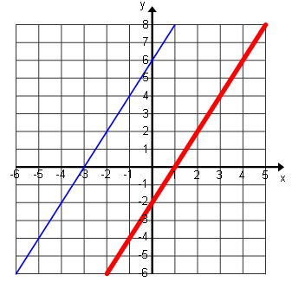  g(x): Steeper Less Steep Same Steepness  $$g(x)$$  $$f(x)$$  Same steepness and shifted ____ units | Write the new function and determine the steepness.  $3. f\left(x\right)=2x+3$  $$g(x)=f(2x)=___________________$$  $= ___________________$  g(x): Steeper Less Steep Same Steepness  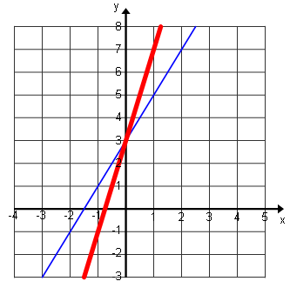  $$g(x)$$  $$f(x)$$
Write the new function and determine the steepness.  $$2. f\left(x\right)=2x+6$$  $g(x)=f(x+4)=______________$  $=______________$  g(x) translates: Up Down Left Right  g(x): Steeper Less Steep Same Steepness  $$g(x)$$  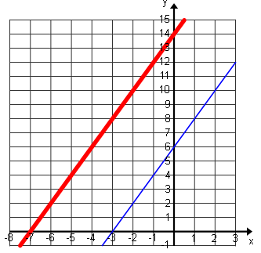  $$f(x)$$  Same steepness and shifted ____ units  Reflection:  $$f\left(x-c\right)means: f(bx) means$$ | Write the new function and determine the steepness.  $4. f\left(x\right)=2x+3$  $$g(x)=f(\frac{1}{3}x)=__________________$$  $= __________________$  g(x) translates: Up Down Left Right  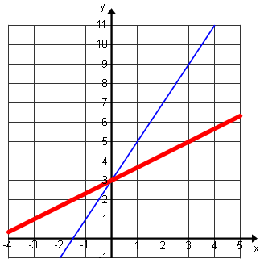  g(x): Steeper Less Steep Same Steepness  $$f(x)$$  reflection  $$g(x)$$
Write the new function and determine the steepness.  $1. f\left(x\right)=2x+3$  $$g(x)=f(-x)=__________________$$  $= __________________$  g(x): Steeper Less Steep Same Steepness  reflection across the y-axis  $$f(x)$$  $$g(x)$$  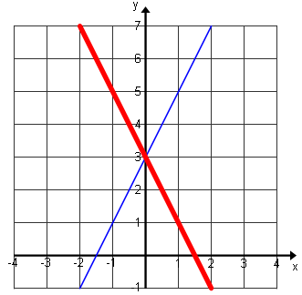 | Write the new function and determine the steepness.  $2. f\left(x\right)=2x+3$  $$g\left(x\right)=-f(x)=_________________$$  $= _________________$  g(x): Steeper Less Steep Same Steepness  reflection across the x-axis  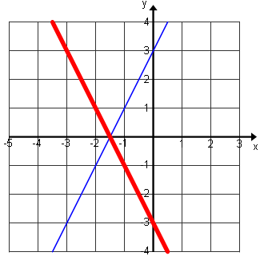  $$g(x)$$  $$f(x)$$

