Notes: Linear Parent Function: $f(x)=x$
Name _________________________________________ Date ___/___/___
Transformation from the Parent function
Effects on Slope
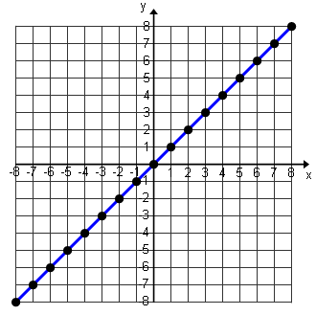
Written in Slope - Intercept Form: $f(x)=mx+b$

$y=x or f(x)=x$

m=_______ b=__________

$$f\left(bx\right)=___________________________________$$
a$f\left(x\right)=___________________________________$
$$1. f(x)=x g(x)=f(3x)= ______________$$  g(x): Steeper Less Steep Same Steepness  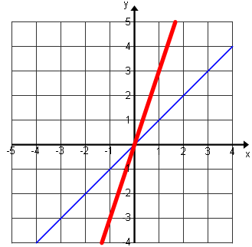  reflection  $$g(x)$$  $$f(x)$$ | $$2. f(x)=x g(x)=3f(x)= ______________$$  g(x): Steeper Less Steep Same Steepness  reflection  $$g(x)$$  $$f(x)$$
$$11. f\left(x\right)=x g\left(x\right)=f\left(\frac{1}{3}x\right)=_____________$$  g(x): Steeper Less Steep Same Steepness  reflection  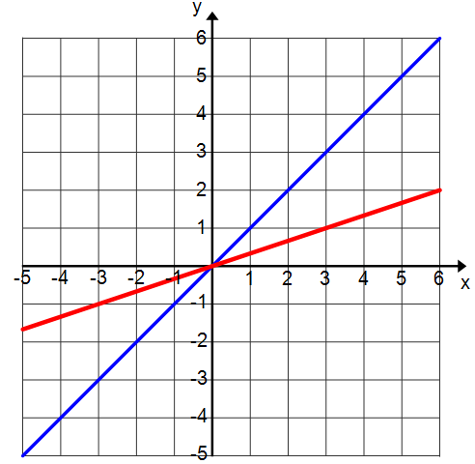  $$f(x)$$  $$g(x)$$ | $$12. f\left(x\right)=x g\left(x\right)=\frac{1}{3}f\left(x\right)=_____________$$  g(x): Steeper Less Steep Same Steepness  reflection  $$f(x)$$  $$g(x)$$
$$5. f\left(x\right)=x g(x)=f(-x)= _____________$$  g(x): Steeper Less Steep Same Steepness  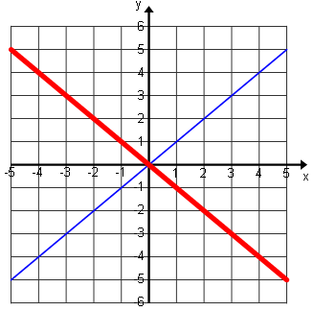  reflection  $$g(x)$$  $$f(x)$$ | $$6. f\left(x\right)=x g\left(x\right)=-f\left(x\right)=_______________$$  g(x): Steeper Less Steep Same Steepness  reflection  $$f(x)$$  $$g(x)$$
$$1. f(x)=x g(x)=f(x-4)=______________$$  g(x) translates: Up Down Left Right  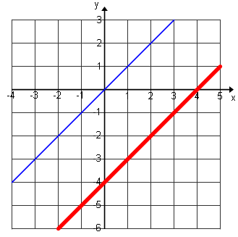  $$f(x)$$  Same steepness and shifted ____ units  $$g(x)$$ | $$2. f\left(x\right)=x g\left(x\right)=f\left(x\right)-4=______________$$  g(x) translates: Up Down Left Right  Same steepness and shifted ____ units  $$g(x)$$  $$f(x)$$
$$5. f(x)=2x g(x)=f(x+4)= ______________$$  g(x) translates: Up Down Left Right  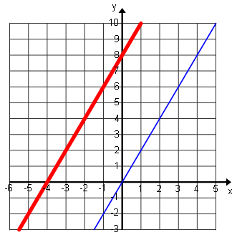  $$f(x)$$  $$g(x)$$  Same steepness and shifted ____ units | $$6. f\left(x\right)=2x g\left(x\right)=f\left(x\right)+4= _______________$$  g(x) translates: Up Down Left Right  $$f(x)$$  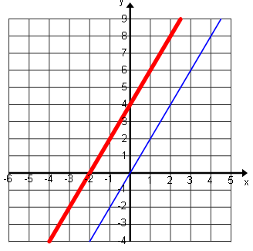  $$g(x)$$  Same steepness and shifted ____ units

