Name: _____________________________________ Period _____ Date ____/____/____

**Reviewing Systems**

1. Given the tables below, write the system.

|  |  |  |
| --- | --- | --- |
| **Hours** | **$ Day 1** | **$Day 2** |
| 0 | 40 | 85 |
| 1 | 70 | 110 |
| 2 | 100 | 135 |
| 3 | 130 | 160 |

|  |  |  |
| --- | --- | --- |
| **Hours** | **$ Day 1** | **$Day 2** |
| 0 | 30 | 75 |
| 1 | 50 | 100 |
| 2 | 70 | 125 |
| 3 | 90 | 150 |

2. A cashier has 3 more dimes than nickels and twice as many nickels as quarters. Find the number of each kind of coin if the total value of the coins is $3.05. **(Remember nickels are worth $0.05 and quarters are worth $0.25.)**

3. Green Computers, Inc. charges a flat rate of $30 per hour for computer services. Their competitor Class A Computers charges an initial fee of $70, but charges $3 less per hour than Green Computers. Write the system that represents this situation.

4. On a wall inside a shoe store a display shows basketball shoes and running shoes. There are a total of 175 pairs in the display. There are 2.5 times as many basketball shoes as there are running shoes. How many pairs of basketball shoes and running shoes are on display?

__________ Basketball Shoes

__________ Running Shoes

5. There are 168 laptops and desktops in a computer lab. There are 14 more laptops than desktops. What is the total number of laptops in the lab?

6. It costs $15,000 for a rent to own car. It will take Marco 18 months to own the vehicle if he starts with $6000 and adds $500 per month. If Marco starts with $3000 and adds $400 per month, how much more time will it take for him to own the vehicle?

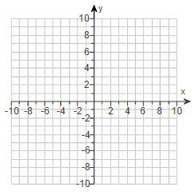7. Use any method to determine the value of x in the solution to the system of equations below.

*3y* − 2*x* = 3

3*x* − 2*y* = 8

1. 6
2. 5
3. No solution
4. Infinite solutions

8. What is the value of y in the solution to the system of equations below?

*y* = − *x* + 2

3*x* − *y* = −13

**Use the scenario below to answer questions 9 and 10.**

9. An Ice cream company sells gallons of ice cream. The company has fixed costs of $25,000, and each gallon of ice cream take an additional $5 to make. The company sells each gallon of ice cream for $10. The graph of a system of linear equations representing the company’s costs and revenue for manufacturing and selling x gallons of ice cream is shown below.

[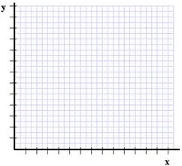](https://www.bing.com/images/search?q=1st+quadrant+coordinate+grid&view=detailv2&&id=838DC269A88783E50E84DE19B586B5AA6C518826&selectedIndex=40&ccid=662GZbAu&simid=607989833208562978&thid=OIP.Mebad8665b02e11e4a3bd97348301e891H0)

Number of Gallons

Dollars (in thousands)

Y= 10x

Y= 25000 + 5x

Revenue

Costs

How many gallons of ice cream will the company need to sell in order for the costs and revenue to be equal?

1. 3,000
2. 5,000
3. 30,000
4. 50,000

10. Using the given graph and equations above, at what amount will the revenue be equal?

1. 3,000
2. 5,000
3. 30,000
4. 50,000

11. A new spiral notebook contains 40 more sheets of paper than a new memo book. The total number of sheets of paper in 4 spiral notebooks and 6 new memo books is 1080. Which system of equations can be used to find s, the number of sheets of paper in one new spiral and m, the number of sheets of paper in one new memo book?

A. 4s +6m = 1080 B. 6s + 4m = 1080 C. 4s + 6m = 1080

S –m = 40 m – s = 40 m –s= 40

12. Solve the system by graphing.

X = 3

Y= 5

Which below best describes the solution?

1. (3,5)
2. (5,3)

13. There are 10 books stacked on a shelf. The thickness of the books are either 1 or two inches. The height of the stack of the 10 books is 16 inches. Which system of equations can be used to determine x, the number of 1-inch books in the stack and y, the number of 2-inch thick books?

A. x +y = 10 B. x + y = 16 C. x + y = 10 D. x + y = 10

2x + y = 16 x + 2y = 10 x +2y= 16 2x + y = 16

14. A college student needs 12 classes that are worth a total of 50 credits in order to complete her degree. The college offers both 4-credit classes and 3-credit classes. Which system of equations can be used to determine f, the number of 4-credit classes the student can take to complete her degree, and h, the number of 3-credit classes?

A. f + h = 12 B. f + h = 50 C. f + h = 12 D. f + h = 50

4f +3h = 50 4f + 3h = 12 4h + 3f = 50 4f + 3h = 12

15. Wildcat Wireless cell phone plan costs $30 a month and an additional $.10 per text message sent or received. Crazy Cub Phone Company charges $40 per month but only charges $.05 per text. Write a system of equations that can be used to determine C, the total cost of the plan, in relation to t, the number of text messages sent for one month.

16. What is the solution to the system of equations below?

1. (3, -2)
2. (-3, -2)
3. (-3, 2)
4. (3, 2)

17. Mark the carpenter makes and sells tables. Use the graph to estimate how many tables the carpenter must sell to break even.

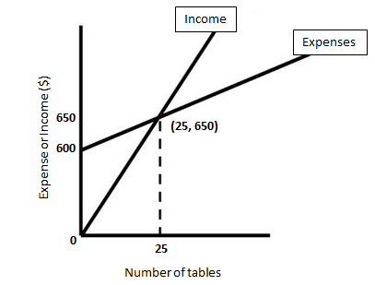

1. Mark must sell 25 tables to break even.
2. Mark must sell 650 tables to break even.

18. A boy has 210 prize tickets he wants to exchange for action figures at a prize booth. At this prize booth 4 tickets can be exchanged for a large action figure, and **5 tickets can be exchanged for 2 small action** figures. The boy wants 2 times as many small action figures as large action figures. Write the system and find the solution.