Solving Systems of Linear Equations – Substitution
Essential Question: How can you use substitution to solve a system of linear equations?
System of linear Equations:

Solution:

Step 1: Solve one of the equations for one of the variables
Step 2: Substitute the expression from Step 1 into the other equation and solve for the other variable.
Step 3: Substitute the value from Step 2 into one of the original equations and solve.

Examples:
- x + y = –7 b. x – 6y = –11 c. 4x + y = –1
–5x + y = 5 3x + 2y = 7 3x – 5y = –18
Step 1: Step 1: Step 1:

Step 2: Step 2: Step 2:

Step 3: Step 3: Step 3:

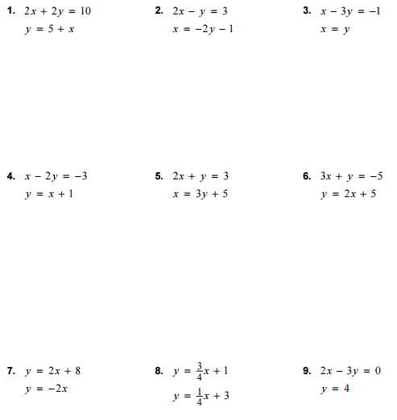
Practice:

