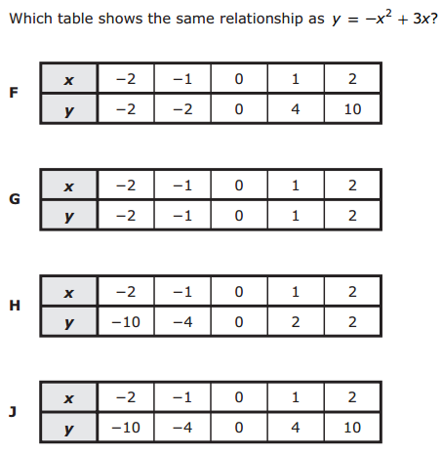

1.

2.

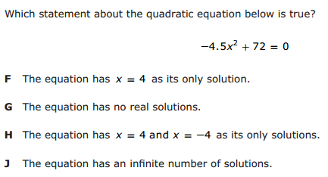

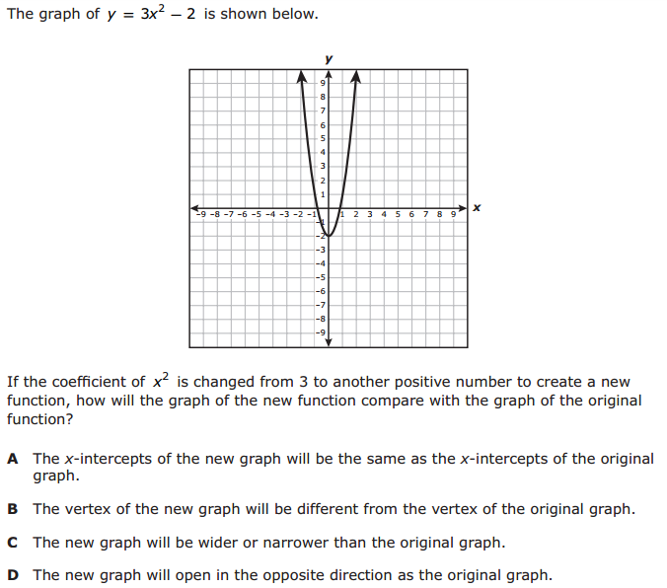

3.

4.

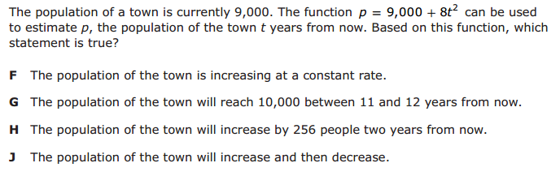

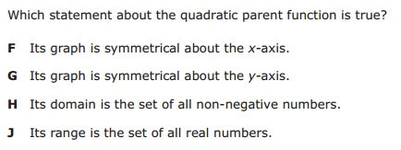

6.

5.

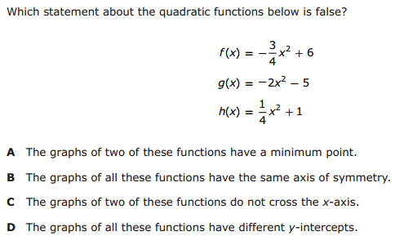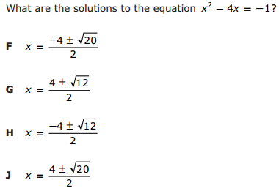

7.

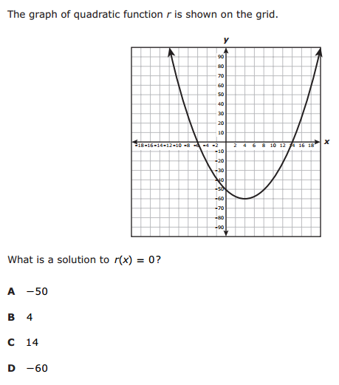

8.

9.

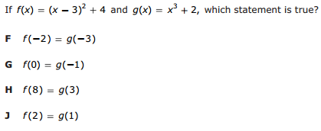

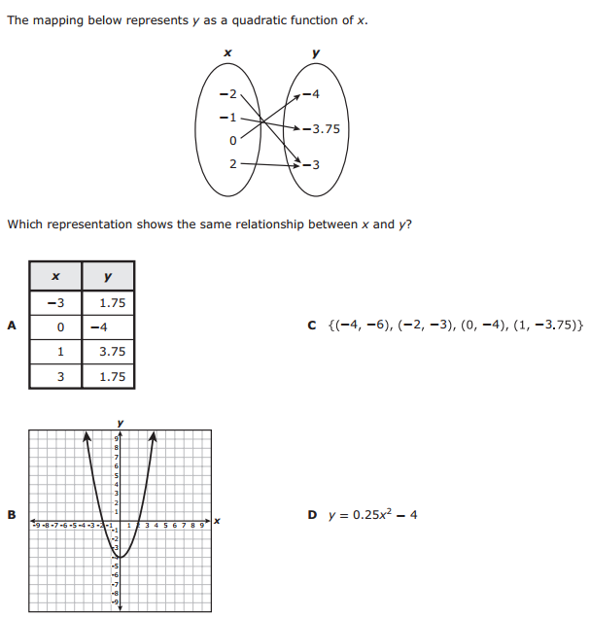

11.

10.

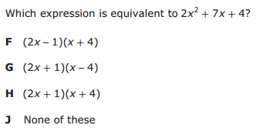

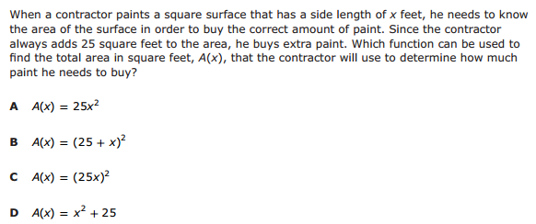

13.

12.

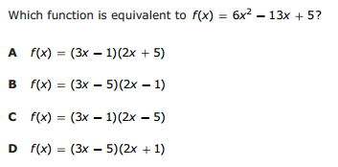

14.

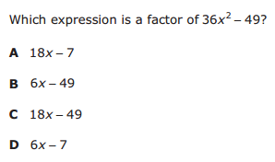

15.

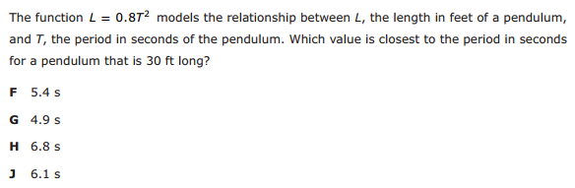

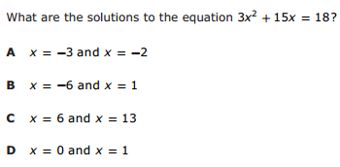

17.

16.

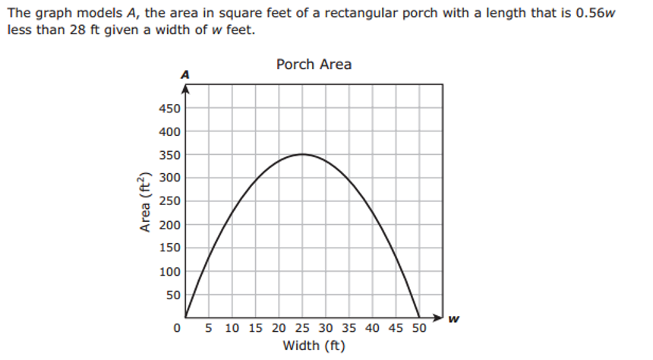

What is the maximum area of the porch? ____________________________________________

What is the width in feet of the porch with the greatest area? ___________________________

What is the largest width the porch can have? ________________________________________

What is $f(15)?$ $f(30)?$

______________________________ ______________________________

What is the input when the output is 225? ______________________

True or False? $f\left(5\right)=f(45)$ True or False? $f\left(15\right)=f(40)$

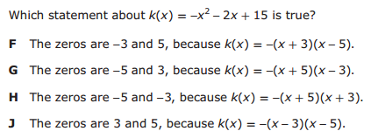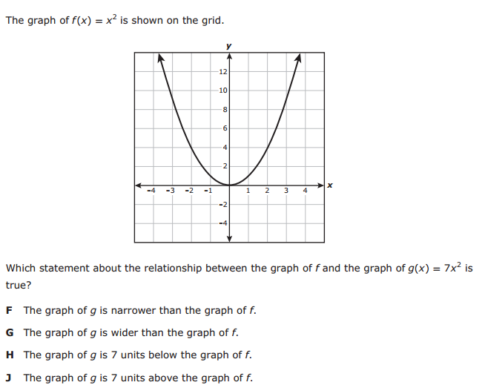

19.

18.

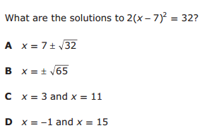

20.

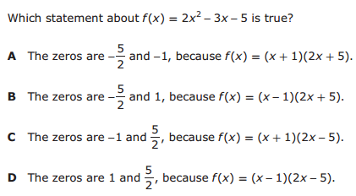

22.

21.

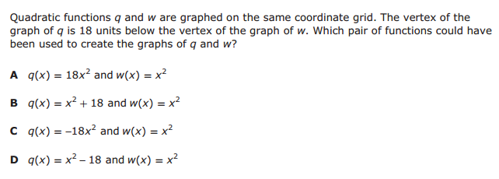

23.

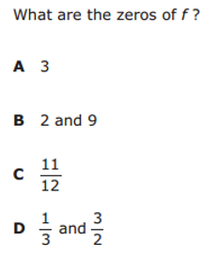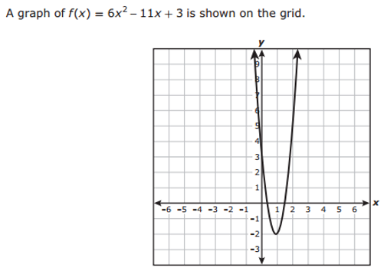

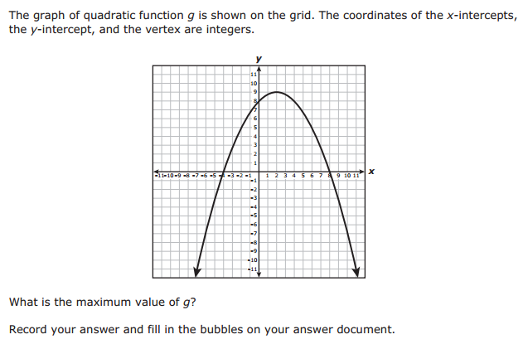

24.

25.

