Let’s review what we did a long time ago.
Based on the value of a and c, what is the transformation of the graph?
y = 5x²+6

f(x) = $\frac{1}{4}$ x²-8

g(x) = - $\frac{2}{3}$x²+5

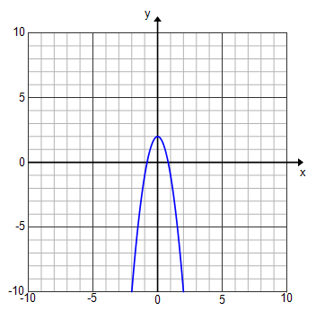
Based on the given graph, what can you tell me about the value of a and c of each graph?

What are the zeros of the following functions?
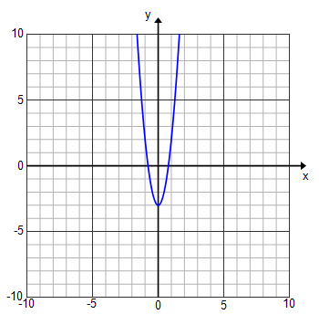
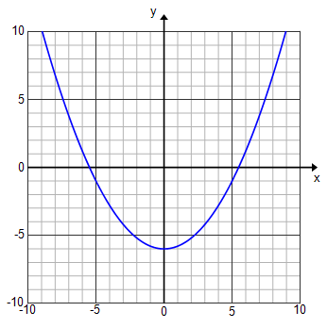
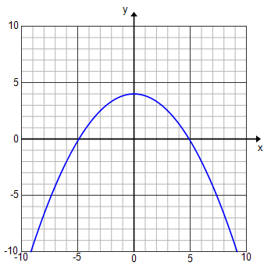
$f\left(x\right)={\frac{1}{7}x}^{2}+3$ $f\left(x\right)={2x}^{2}-6$ $f\left(x\right)= -\frac{2}{5}x^{2}$ + 5

