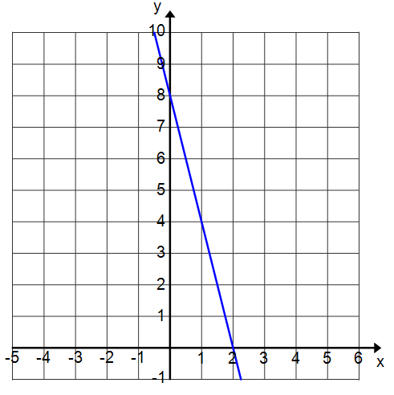
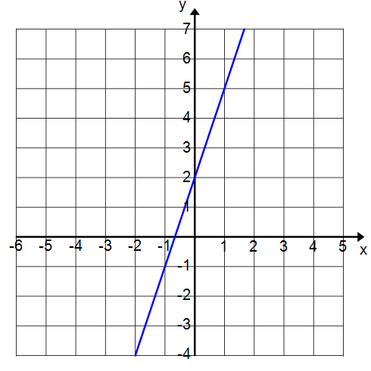
Parallel Lines | Perpendicular Lines
Write an equation in slope-intercept form of the line that passes through $(1, 3)$ and is parallel to $y=3x+2$. | Write an equation in slope-intercept form of the line that passes through $(1, 3)$ and is perpendicular to $y=3x+2$.
Write an equation in slope-intercept form of the line that passes through $(-3, 2)$ and is parallel to $4x+y=9$. | Write an equation in slope-intercept form of the line that passes through $(-3, 2)$ and is perpendicular to $y-1=-4(x-2)$.
Write an equation in slope-intercept form of the line that passes through $\left(-3, 2\right)$and is parallel to $-2x+y=-5$. | Write an equation in slope-intercept form of the line that passes through $\left(-3, 2\right)$and is perpendicular to $y+3=2x-2$.

Name __________________________________________________Date ___/___/___ Period ___
Parallel and Perpendicular lines

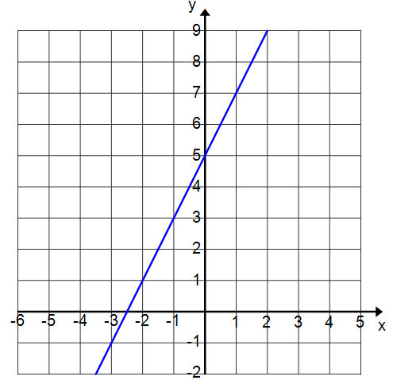

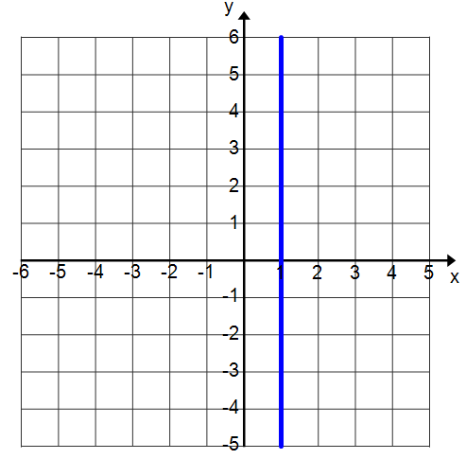
Parallel Lines | Perpendicular Lines
Write an equation in slope-intercept form of the line that passes through $(1, 3)$ and is parallel to $x=1$ | Write an equation in slope-intercept form of the line that passes through $(1, 3)$ and is perpendicular to $x=1$.
Write an equation in slope-intercept form of the line that passes through $(-3, 2)$ and is parallel to $y=2$. | Write an equation in slope-intercept form of the line that passes through $(-3, 2)$ and is perpendicular to $y=2$.
Write an equation in slope-intercept form of the line that passes through $(-5, -6)$and is parallel to the $x-axis$. | Write an equation in slope-intercept form of the line that passes through $(-5, -6)$and is perpendicular to the $x-axis$.
Write an equation in slope-intercept form of the line that passes through $(4, -3)$and is parallel to the $y-axis$. | Write an equation in slope-intercept form of the line that passes through $(4, -3)$and is perpendicular to  the $x-axis$.

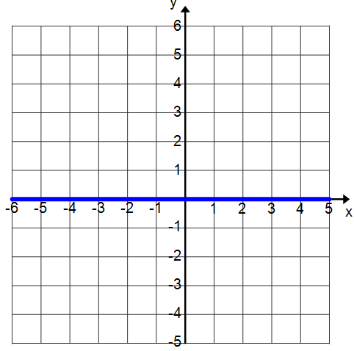
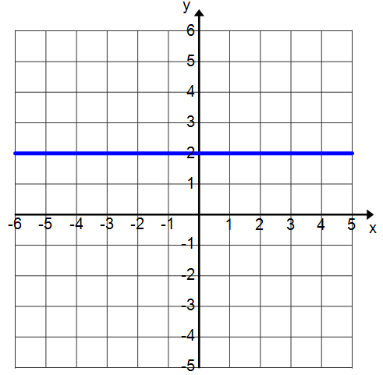

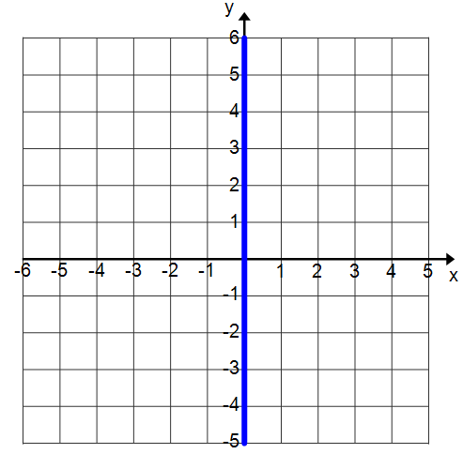

Write an equation of a line that passes through $(5, -2)$ and is parallel to $y=-1$.  Name __________________________________________________Date ___/___/___ Period ___  Parallel and Perpendicular Lines - Homework | Write an equation of a line that passes through $(-5, -6)$ and is perpendicular to the x-axis.
Write an equation of a line that passes through $(-7, 2)$ and is perpendicular to $-4x+y=6$. | Write an equation in slope-intercept form of the line that passes through $\left(-1, 3\right)$ and is parallel to $y=4x+5$.
Write an equation in slope-intercept form of the line that passes through $(-3, 4)$ and is parallel to $y=-2x+ 5$. | Write an equation of a line that passes through the origin and is perpendicular to $y-2=\frac{3}{4}\left(x+1\right)$.
Name ________________________________________________ Date __/___/___ Period ___
Parallel and Perpendicular Lines - Classwork

