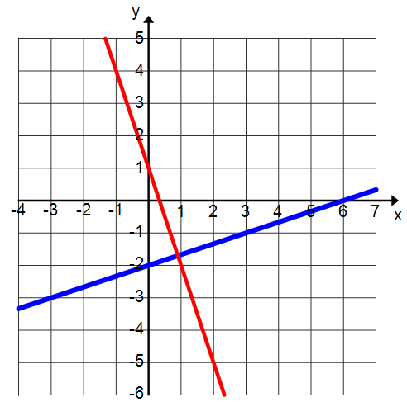 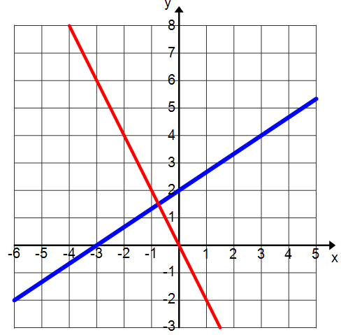

|  |  |  |
| --- | --- | --- |
| What must you know about two lines before determining if they are parallel or perpendicular?  Is the slope always seen in the equation? Y or N  Which below shows the slope?   1. B. C. D. E. F.   Which below does not show the slope?   1. B. C. D. E. F. | | |
| Are these lines parallel, perpendicular, or neither? Why ? | $x=-5$ $$x=-4$$ | $$y=2$$ $$x=3$$ |
| $y=\frac{4}{5}x-1$ $y=\frac{4}{5}x+29$ | $y-2=-\frac{1}{3}\left(x-5\right)$ $-3x+y=15$ |
| Are these lines parallel, perpendicular, or neither? Why ? | $$y=4x$$ $$y=-4$$ | $$y=3$$ $$x=3$$ |
| $-2x+y=7$ $y=2x+3$ | $y=2x+5$ $y=-2x+1$ |

Name _____________________________________________________ Period _____Date ___/____/____

Parallel and Perpendicular lines

Name _____________________________________________________ Period _____Date ___/____/____

Parallel and Perpendicular lines



|  |  |  |  |  |  |  |
| --- | --- | --- | --- | --- | --- | --- |
| **Determine which graph(s) does not belong in each column Is the graph parallel, perpendicular, or neither?**  Name _____________________________________________________ Period _____Date ___/____/____  Parallel and Perpendicular lines | | | | | | |
|  | | |  | | | |
|  | | |  | | | |
|  | | |  | | | |
|  | | |  | | | |
| **Determine whether the equations are parallel, perpendicular, or neither.** | | | | | | |
| $y=x+11$ $y=-x+2$ | | $y-4=-\frac{3}{2}\left(x+1\right)$ $y-2=-\frac{2}{3}\left(x-5\right)$ | | | $-2x+y=7$ $y=2x+3$ | |
| $y=\frac{3}{4}x-1$ $$y=\frac{3}{4}x+29$$ | | $y-2=-4\left(x-5\right)$ $\frac{1}{4}x+y=15$ | | | $y=4x-2$ $-x+4y=0$ | |
| $y=\frac{2}{3}x-1$ $3x-2y=5$ | | $x=-2$ $$x=-1$$ | | $y=7$ $$y=-7$$ | $x=-2$ $x=\frac{1}{2}$ | $$y=-7$$ $$x=-7$$ |
| $$y=2$$ $$x=3$$ | $$y=7x$$ $$y=-\frac{1}{7}x$$ | $$y=7x$$ $$y=-7$$ | | $$x=-\frac{1}{2}$$ $$y=-2x$$ | A vertical line and the x-axis | A horizontal line and the x-axis |