Make Up Assignment
- Solve the following system by substitution:
$x-3y=-17$
$6x-2y=-22$

- Solve the following system by elimination:
$2x+3y=29$
$-x-y=-10$

- Solve the following inequalities for x and graph them on the number line.
$$3\left(2x-5\right)≤21$$  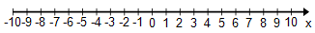 | $$11< 5x+1 ≤ 21$$

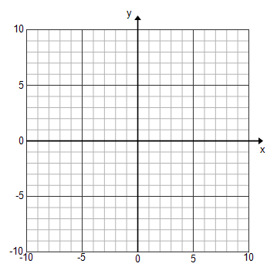
- Graph the following inequalities on the coordinate plane and shade appropriately.
$y ≥\frac{-3}{4}x+1$ $y<2x-4$

- Graph the system of inequalities and shade appropriately.
$$y>-x-4$$
$$y≤2x+2$$
