|  |  |  |  |  |  |  |  |  |  |  |  |  |  |
| --- | --- | --- | --- | --- | --- | --- | --- | --- | --- | --- | --- | --- | --- |
| **Example 1)** Determine if the following mapping represents a function by using the 1-to-1 test and a table. Justify your answer.   |  |  | | --- | --- | | **Input** | **Output** | |  |  | |  |  | |  |  | |  |  |   **Justification:** | **Example 2)** Determine if the following mapping represents a function by using the 1-to-1 test and a table. Justify your answer.  **Justification**: | | **Example 3) Create an scenario to describe the graph below.**    **Justification** |
| **Example 4)** Determine if the following mapping represents a function by using the 1-to-1 test and a table. Justify your answer.   |  |  | | --- | --- | | **Input** | **Output** | |  |  | |  |  | |  |  | |  |  | |  |  |   **Justification:** | **Example 5)** Determine if the following ordered pairs {(2,3), (-2,3), (4,7), (2,4), (-2,3)} represents a function. Justify your answer.  **Justification:**  Determine if the following order pairs {(0,3),(1,3),(2,3),(-1,-3), (3,7)} represents a function. Justify your answer.  **Justification:** | **Example 6) Does the scenario below describes the graph? Y or N**  The level of water in a bucket stays constant. A steady rain raises the level. The rain slows down. Someone dumps the bucket.    **Justification:** | |

Objective(s) : _________________________________________________________________________________________________________________________

Questions:

------------------------------------------------------------------------------------------------------------------------------------------------------------------------------------------------------------------------------------------------------------------------------------------------------------------------------------------------------------------------------------------------------------------------------------------------------------------------------------------------------------------------------------------------------------------------------------------------------------------------------------------------------------------------------------------------------------------------------------------------------------------------------------------------------------------------------------------------------------------------------------------------------

Name __________________________ Period _____ Date ___/___/___

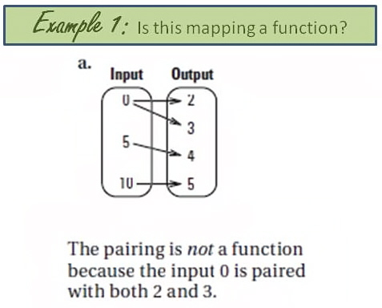

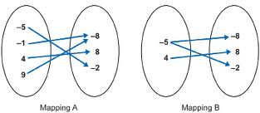

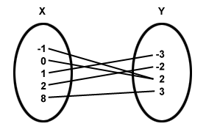

**You Do**

Make sure to use resources and check your work as you go!

|  |  |  |  |  |
| --- | --- | --- | --- | --- |
| **1)** Determine if the following mapping represents a function by using the 1-to-1 test and a table. Justify your answer.  **Justification:** | | 2)A car comes upon a school zone and must slow down. A constant rate of speed is kept while in the school zone, then the care speeds back up when out of the school zone. | | **3)** Determine if the following order pairs {(3,3),(-3,3),(3,1)} represents a function. Justify your answer.  **Justification:** |
| Create a scenario that would describe the graph. | **5)** Determine if the following ordered pairs {(4,2),(-3,3),(6,1),(2,3)} represents a function. Justify your answer.  **Justification:** | | **6)** Determine if the following mapping represents a function by using the 1-to-1 test and a table. Justify your answer.  **Justification:** | |

Questions:

---------------------------------------------------------------------------------------------------------------------------------------------------------------------------------------------------------------------------------------------------------------------------------------------------------------------------------------------------------------------------------------------------------------------------------------------------------------------------------------------------------------------------------------------------------------------------------------------------------------------------------------------------------------------------------------------------------------------------------------------------------------------------------------------------------------------------------------------------------------------------------------------------------------------------------------------------------------------------------------------------------------------

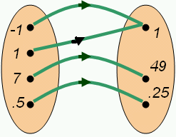

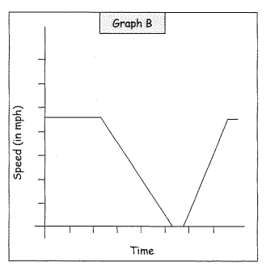

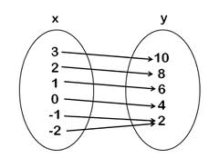

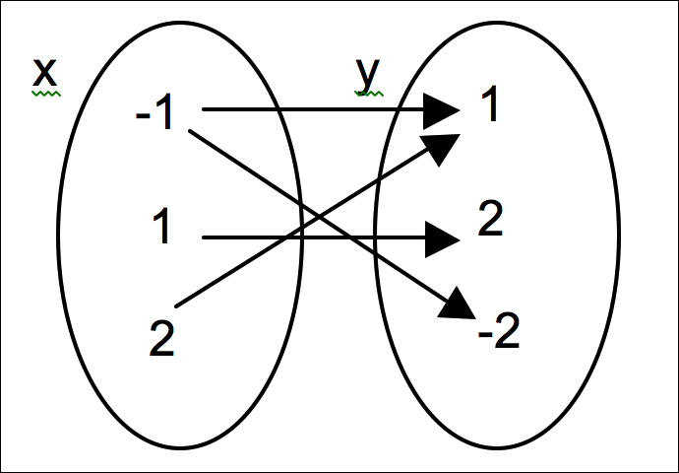

|  |  |  |
| --- | --- | --- |
| **7)** Determine if the following mapping represents a function by using the 1-to-1 test and a table. Justify your answer.  **Justification:** | **8)** Determine if the graph is a function or relation. | 9. A pet store is selling puppies for $50 each. It has 8 puppies to sell. Sketch a graph for this situation. |
| **10)** Determine if the following mapping represents a function by using the 1-to-1 test and a table. Justify your answer.    **Justification:** | Create a scenario that would describe the graph. | **12)** Determine if the graph below represents y as a function of x |

Questions:

---------------------------------------------------------------------------------------------------------------------------------------------------------------------------------------------------------------------------------------------------------------------------------------------------------------------------------------------------------------------------------------------------------------------------------------------------------------------------------------------------------------------------------------------------------------------------------------------------------------------------------------------------------------------------------------------------------------------------------------------------------------------------------------------------------------------------------------------------------------------------------------------------------------------------------------------------------------------------------------------------------------------

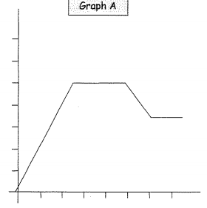

Summary : _________________________________________________________________________________________________________________________ ______________________________________________________________________________________________________________________________________________________________________________________________________________________________________________________________________