Homework
$$5 + 6x > -19 or 10 + 6x < -20$$  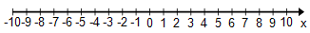 | $$3x + 6 + x > -22$$
$$15< -5(x -2)$$  Write your answer in words: | $-16≤2\left(6x-5\right)<14$  Write your answer in words:
$$2-4\left(x +3\right)≤6$$  Write your answer in words: | $$2 – (-18x – 16) ≥ -18$$  Write your answer in words:
$$4x + 1 > -9 + 6x$$  Write your answer in words: | $$-4(x - 7) ≤ -9x – 17$$  Write your answer in words:

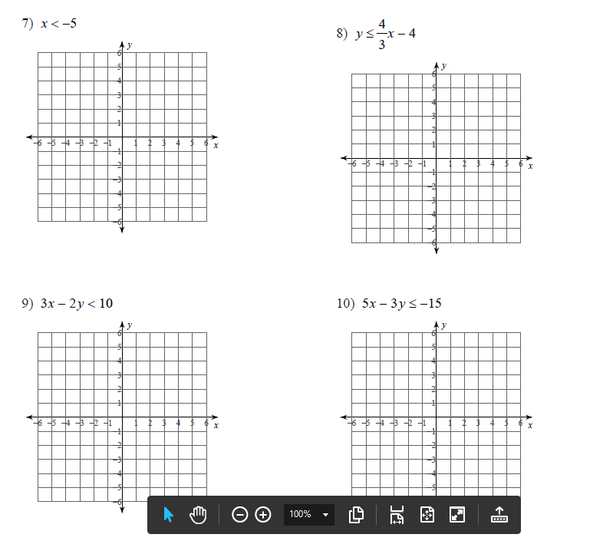
Graph the following linear inequalities:

