Notes
Inequalities:
< | > | < | >
________________ | ________________ | _______________________ | ______________________
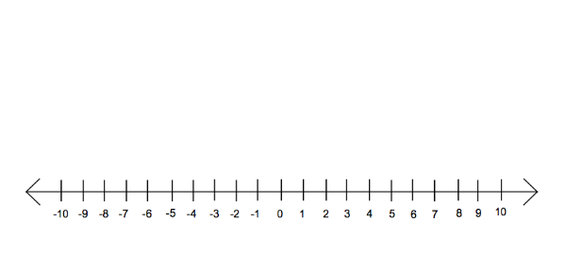

Graphing on a Number Line:
x < -3
We read it as “x is less than negative three”. Think about what numbers x could be if it is less than negative 3.

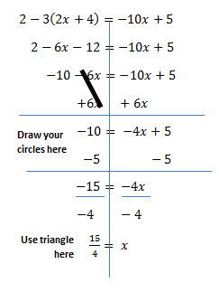
Remember solving rules are the same EXCEPT you switch the inequality when you multiply or divide by a negative number.
Examples: Switch inequality when
                - -3x < 15 becomes x > -5

                - $\frac{x}{-4}$ > 5 becomes x < -20

                - 10 > x becomes x < 10

$$11 < 5x + 1$$  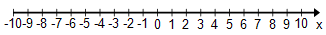  Write your answer in words: | $$5x +1 ≤ 21$$  Write your answer in words:
$$11< 5x+1 ≤ 21$$

Write your answer in words:

$$15<3\left(x+2\right)$$  Write your answer in words: | $$3\left(x+2\right)< 24$$  Write your answer in words:
$$15<3\left(x+2\right)<24$$

Write your answer in words:

$$-2x +4>10$$  Write your answer in words: | $$-2x +4>-8$$  Write your answer in words:
$-2x +4>10$ OR $-2x +4>-8$

Write your answer in words:

$$3-(x +5)≥2$$  Write your answer in words: | $$4x-(2x-1)≥3$$  Write your answer in words:
$3-(x +5)≥2$ OR $4x-(2x-1)≥3$

Write your answer in words:

Reflection: What have you learned?

