Define:

Systems of Linear Equations:

____________________________________________________________________________________________________________________________________________________________________________________________________

Solution:

____________________________________________________________________________________________________________________________________________________________________________________________________

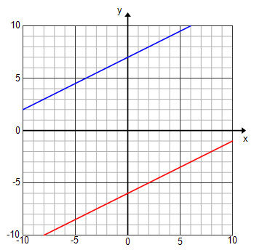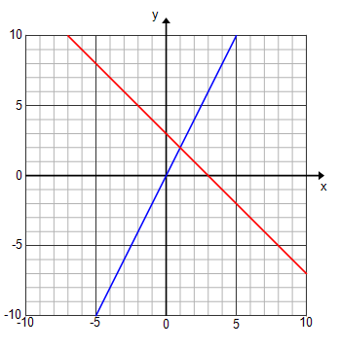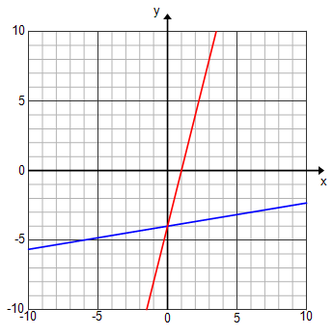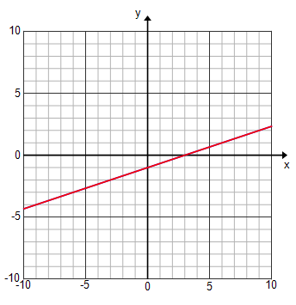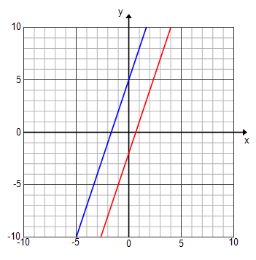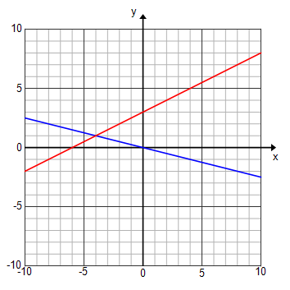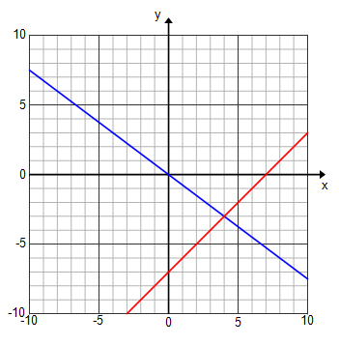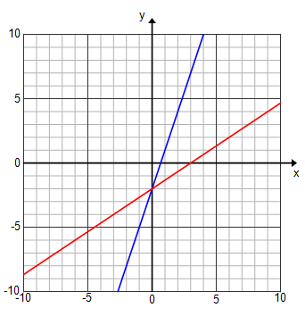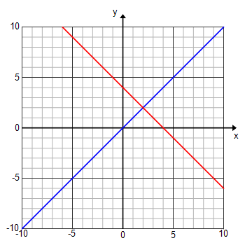

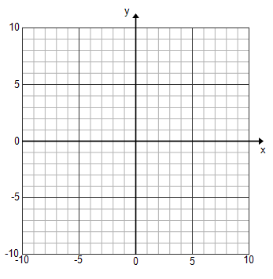Graph and identify the solution.

1. $y = 2x + 4$ 2. $y = 3x – 2$



$y = 2x + 4$ $y = 1/2x +3$

1. $y = x -2$ 4. $y = 4x - 3$

$y = 1/6x + 3$ $y = 4x +5$