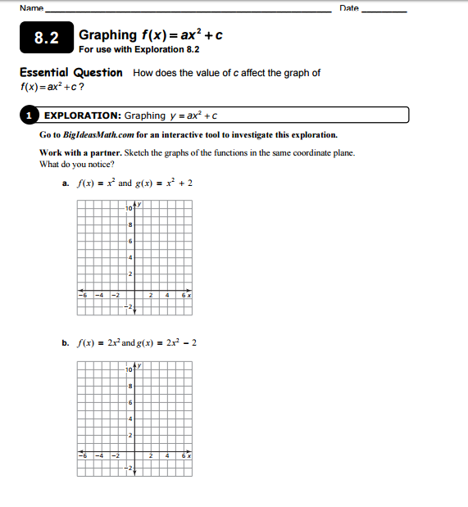

What do you notice when the value of c is positive?

What do you notice when the value of c is negative?

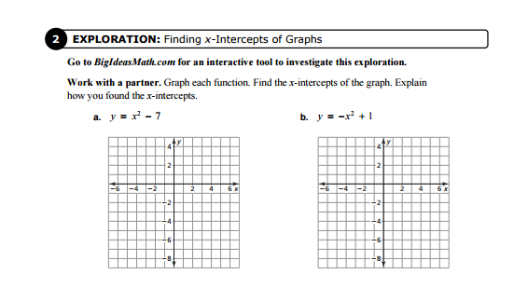
Steps for finding zeros or x-intercept using the calculator:
- Open a new graph.
- Enter equation into f(x).
- Push “MENU”
- Push “6” (Analyze Graph)
- Push “1” (Zero)
- Scroll the line to the left of one x-intercept. Push “ENTER”.
- Scroll the line to the right of the same x-intercept. Push “ENTER”.
- Repeat steps 3 – 7 for the second x-intercept.

Practice:
For each equation below, describe the graph of the quadratic function.
Does it open up or down? Does it stretch? Does it shift up or down?

- $y=4x^{2}+6$ 2. $y=\frac{3}{5}x^{2}-5$

3. $y=-\frac{1}{3}x^{2}+\frac{1}{3}$ 4. $y=\frac{6}{5}x^{2}+2$

5. $y=-\frac{5}{2}x^{2}-3$ 6. $y=x^{2}-\frac{4}{3}$

For the following graphs, identify the value of c and describe the value of a.
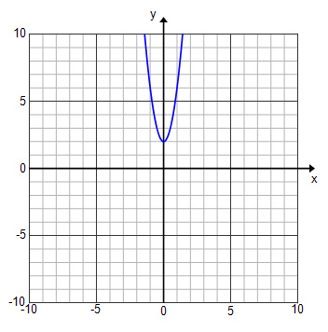
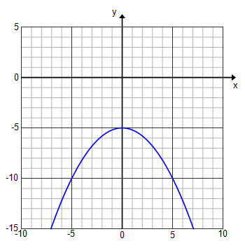
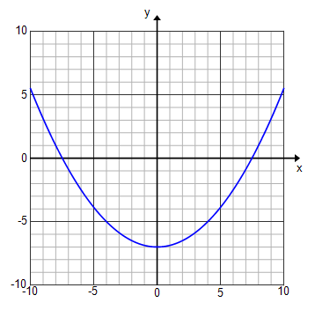
9. 10. 11.

Graph the following equations and find the zeros if they exist.
12. $y=\frac{6}{5}x^{2}-6$ 13. $y=-3x^{2}+2$

14. $y=4x^{2}+5$ 15. $y=\frac{3}{4}x^{2}-3$

