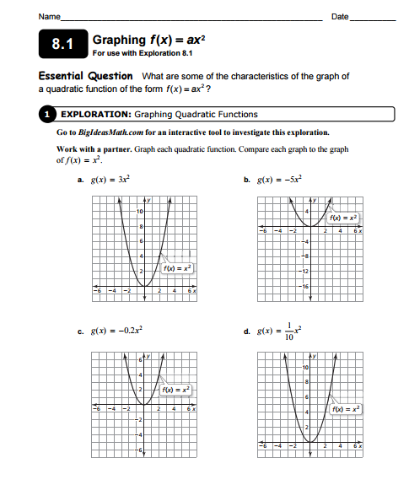

Making Observations:

- What do you notice when 0 < a < 1?

- What do you notice when a > 1?

- What do you notice when -1 < a < 0?

- What do you notice when a < -1?

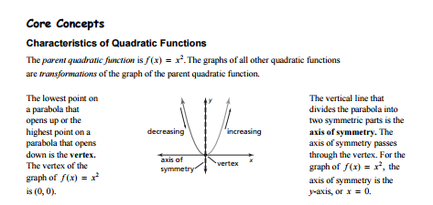

- Based on the graph, what do 2. Based on the graph, what do
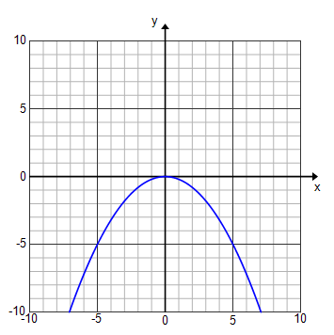
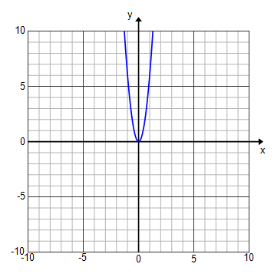
you know about the value of a? you know about the value of a?

- Based on the graph, what do 4. Based on the graph, what do
you know about the value of a? you know about the value of a?
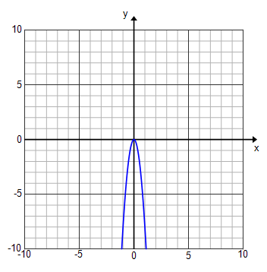
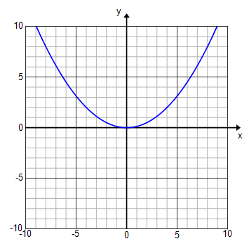

For the following equations, describe what the graph of the quadratic function looks like.
- $y={4x}^{2}$

- $f\left(x\right)= \frac{1}{2}x^{2}$

- $y= -\frac{4}{5}x^{2}$

