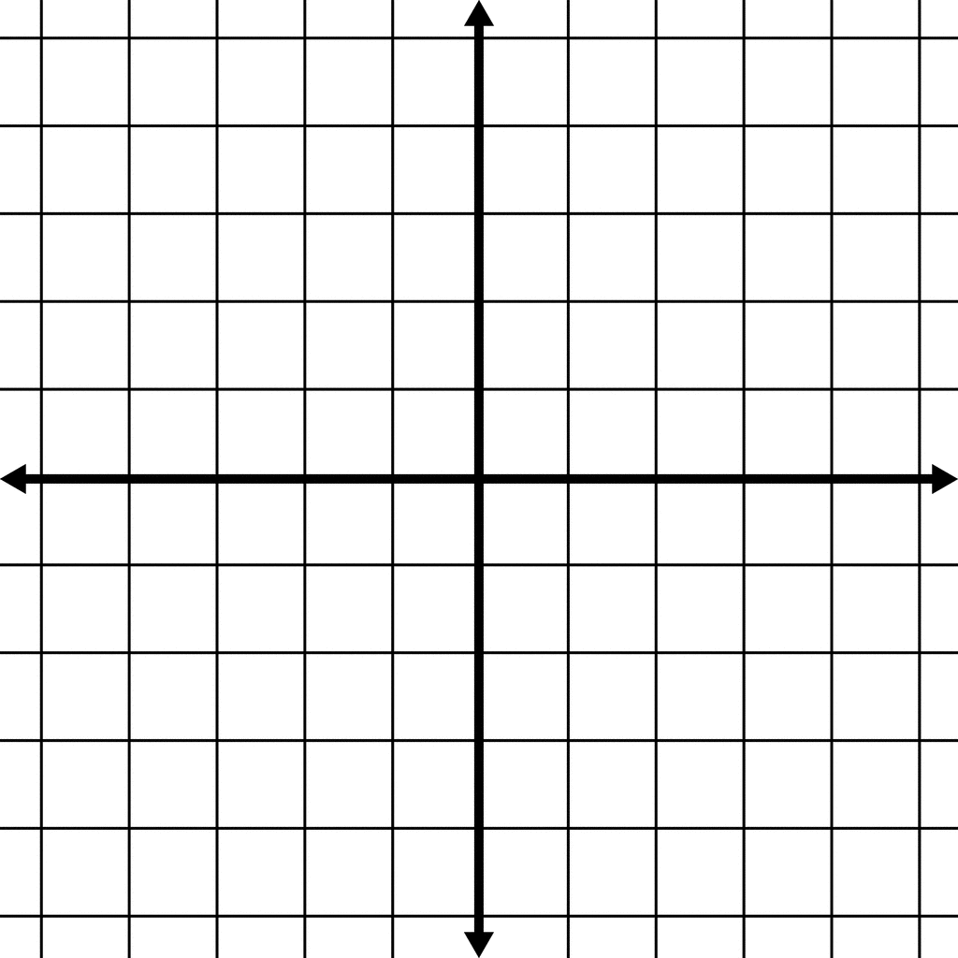  1) $x^{2}-5x+4=0$  x y  y-intercept: ______________________________  Solutions, roots, zeros, and x-ints. x = _____x= _______  Vertex: ______________________________________  Minimum or Maximum circle one  Axis of symmetry: __x =________________________ | 2) ${2x}^{2}-7x+3$  x y  y-intercept: ______________________________  Solutions, roots, zeros, and x-ints. x = _____x= _______  Vertex: ______________________________________  Minimum or Maximum circle one  Axis of symmetry: __x =________________________
3) $x^{2}+x-12=0$  x y  y-intercept: ______________________________  Solutions, roots, zeros, and x-ints. x = _____x= _______  Vertex: ______________________________________  Minimum or Maximum circle one  Axis of symmetry: __x =________________________ | 4) ${2x}^{2}+13x-7$  x y  y-intercept: ______________________________  Solutions, roots, zeros, and x-ints. x = _____x= _______  Vertex: ______________________________________  Minimum or Maximum circle one  Axis of symmetry: __x =________________________
5) $4x^{2}-4x-3$  x y  y-intercept: ______________________________  Solutions, roots, zeros, and x-ints. x = _____x= _______  Vertex: ______________________________________  Minimum or Maximum circle one  Axis of symmetry: __x =________________________ | 6) $4x^{2}-4x+7$  x y  y-intercept: ______________________________  Solutions, roots, zeros, and x-ints. x = _____x= _______  Vertex: ______________________________________  Minimum or Maximum circle one  Axis of symmetry: __x =________________________
7) $3x^{2}+5x-2$  x y  y-intercept: ______________________________  Solutions, roots, zeros, and x-ints. x = _____x= _______  Vertex: ______________________________________  Minimum or Maximum circle one  Axis of symmetry: __x =________________________ | 8) ${-x}^{2}+5x-4$  x y  y-intercept: ______________________________  Solutions, roots, zeros, and x-ints. x = _____x= _______  Vertex: ______________________________________  Minimum or Maximum circle one  Axis of symmetry: __x =________________________

9) ${-2x}^{2}+9x-9$  x y  y-intercept: ______________________________  Solutions, roots, zeros, and x-ints. x = _____x= _______  Vertex: ______________________________________  Minimum or Maximum circle one  Axis of symmetry: __x =________________________ | 10) $x^{2}-25$  x y  y-intercept: ______________________________  Solutions, roots, zeros, and x-ints. x = _____x= _______  Vertex: ______________________________________  Minimum or Maximum circle one  Axis of symmetry: __x =________________________
11) $x^{2}+3x-10$  x y  y-intercept: ______________________________  Solutions, roots, zeros, and x-ints. x = _____x= _______  Vertex: ______________________________________  Minimum or Maximum circle one  Axis of symmetry: __x =________________________ | 12) $x^{2}+5x-6$  x y  y-intercept: ______________________________  Solutions, roots, zeros, and x-ints. x = _____x= _______  Vertex: ______________________________________  Minimum or Maximum circle one  Axis of symmetry: __x =________________________
13) $x^{2}+2x-48$  x y  y-intercept: ______________________________  Solutions, roots, zeros, and x-ints. x = _____x= _______  Vertex: ______________________________________  Minimum or Maximum circle one  Axis of symmetry: __x =________________________ | 14) $x^{2}-7x-30$  x y  y-intercept: ______________________________  Solutions, roots, zeros, and x-ints. x = _____x= _______  Vertex: ______________________________________  Minimum or Maximum circle one  Axis of symmetry: __x =________________________
15) $4x^{2}-19x-30$  x y  y-intercept: ______________________________  Solutions, roots, zeros, and x-ints. x = _____x= _______  Vertex: ______________________________________  Minimum or Maximum circle one  Axis of symmetry: __x =________________________ | 16) ${2x}^{2}-x-21$  x y  y-intercept: ______________________________  Solutions, roots, zeros, and x-ints. x = _____x= _______  Vertex: ______________________________________  Minimum or Maximum circle one  Axis of symmetry: __x =________________________

