GRAPHING LINEAR FUNCTIONS and TRANSFORMATIONS
EXAMPLE 1
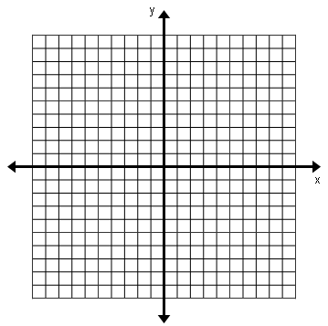
f(x) = x + 2
x | f(x) | f(x) + 5
-2
-1
0
1
2
3

Describe the transformation:

EXAMPLE 2
f(x) = 3x – 2
X | F(x) | F(x) + 4
-2
-1
0
1
2
3

Describe the transformation:

What happens when you add a positive number to the output?

EXAMPLE 3
F(x) = -4x +1
X | F(x) | F(x) – 7
-2
-1
0
1
2
3

Describe the transformation:

EXAMPLE 4
F(x) = 10x – 3
X | F(x) | F(x) - 4
-2
-1
0
1
2
3

Describe the transformation:

What happens when you add a negative number to the output?

