Graphing f(x) = ax² + bx + c
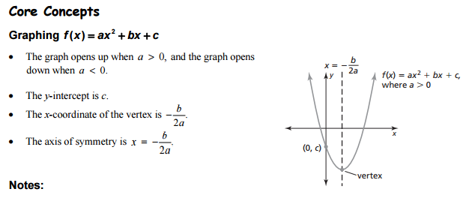
Essential Question: How can you find the vertex of the graph of f(x) = ax² + bx + c?

Example: f(x) = 3x² – 2x + 1
Which way will the graph open? Will it have a maximum or a minimum?

What is the y-intercept?

What is the x-coordinate of the vertex?

What is the axis of symmetry?

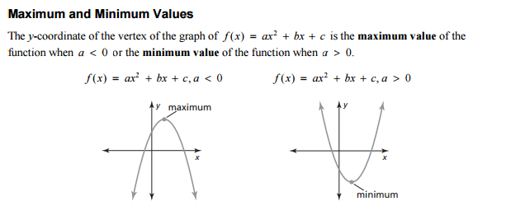

Example: f(x) = 3x² – 2x + 1
Does the function have a minimum or maximum? What is the value of the minimum or maximum?

Practice:
For problems 1-4, find the axis of symmetry and y-intercept of the quadratic function.
- f(x) = x² – 10x + 2 2. y = –4x² +16x

- y = –2x² – 8x + 5 4. f(x) = –3x² + 6x + 1

For problems 5-8, say whether the quadratic function has a maximum or minimum value and find the value.
- y = –1/2x² – 5x + 2 6. y = 8x² + 16x – 2

- y = – x² – 4x – 7 8. y = –7x² + 7x + 5

For problems 9-10, find the following four things, then graph the equation:
- The y-intercept
- The axis of symmetry
- The maximum or minimum value
- The coordinates of the vertex

- f(x) = 3x² + 6x + 2 10. y = 2x² – 8x – 1
- a.

- b.

- c.

- d.

