Name:_______________________________________ Date:________________________ Period:________________
Find the Treasure!
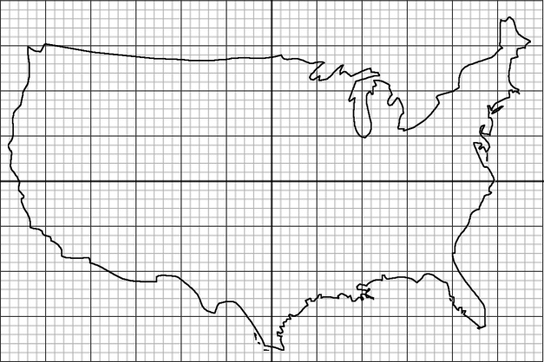
Graph each of the given inequalities and find out which destination holds the hidden treasure.
$y≥x-12$ $y<\frac{1}{6}x+15$ $y<-2x+1$ $y>-11$ $y≥2x+12$

Let’s practice some substitution and elimination!
Substitution:
3x + 2y = 0 x + 6y = -1
4x – y = -11 3x – 2y = 17

Elimination:
2x + y = 15 3x + 2y = 1
-x + 3y = 17 x + y = 2

