Name:__________________________________________Date:________________________Period:__________
FINAL REVIEW DAY 2
Slope-Intercept Form – $y = mx+b$
Identify the slope and y-intercept for problems 1-4.
-3 | -1 | 1 | 3 | 5
11 | 3 | -5 | -13 | -21

- $y = 4x + 17$

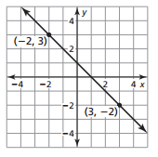

- Jane is a babysitter and makes $15 per hour. She works a total of 25 hours every week and makes $375. If the amount Jane makes is a function of the number of hours she works, what is the slope?

Point-Slope Form – $y-y_{1} = m(x-x_{1})$
For problems 5 – 8, write the equation in point-slope form.
- (-2, 1) and m = -3 6. (3, 5) and m = $-\frac{1}{2}$

- $f\left(2\right)=6, f\left(3\right)=5$ 8. $f\left(-3\right)= -1, f\left(-2\right)=4$

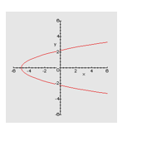
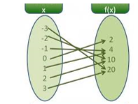
Is It a Function?
- 10.

TRANSFORMATIONS OF QUADRATICS
For problems 11 – 14, identify the transformations of the given function.
- $f\left(x\right)=4x^{2}+5$ 12. $f\left(x\right)= {\frac{1}{2}x}^{2}-2$

- $f\left(x\right)= {-\frac{2}{3}x}^{2}+8$ 14. $f\left(x\right)= {-7x}^{2}-19$

15. $f\left(x\right)= {3x}^{2}+4x-3$ 16. Identify the vertex of the following functions.
a. What is the y-intercept? a. $f\left(x\right)=2(x-4)^{2}+6$

b. What is the x-coordinate of the vertex? b. $f\left(x\right)=(x+3)^{2}+8$

c. What is the axis of symmetry? c. $f\left(x\right)= {(x-9)}^{2}-11$

d. What is the maximum or minimum? d. $f\left(x\right)= {(x+13)}^{2}-6$

e. What are the coordinates of the vertex?

