Name:__________________________________ Date:________________________________ Period:________________

Given this word problem, how would you find the domain and range?
A car can travel 55 miles for each gallon of gasoline. The function d(x) = 55x represents the distance d(x), in miles, that the car could travel with x gallons of gasoline. The car’s fuel tank holds 14 gallons.
First, we must identify certain words or key phrases within the problem.
- ______________ – gives us how we find our _________ and _________.
- ______________ – what two things have a ___________________?
- What are the ___________ and the ____________?
- What ______________ depends on the other?
- Does the problem have a _________________ or ________________?
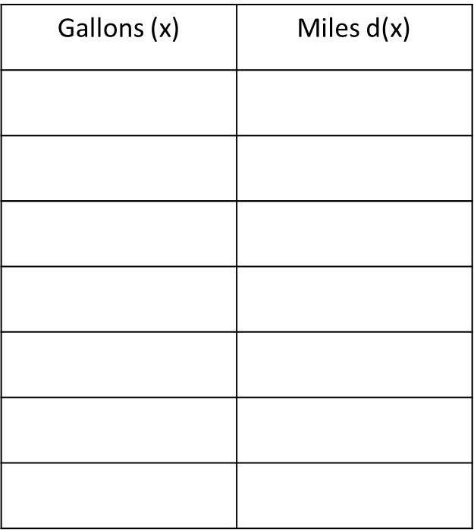
        - Using the function, we can find input and output values.
        - Can we have negative gallons of gas?
        - What is the maximum number of gallons that we can have based on the problem?
        - Is this an example of a discrete or continuous function?
        - Domain:
        - Range:

SUMMARY

Now, let’s find the domain and range of another situation.
The total cost to rent a car is a function of the number of miles driven. A rental car company charges $0.75 per mile driven plus an initial cost of $35.

- Function: ____________________________

- Minimum or maximum:_________________

- Continuous or Discrete?_________________

- Domain:_____________________

- Range:______________________

SUMMARY

