Let’s find the Domain and Range of each graph!
Name __________________________________________________Date ____/____/____
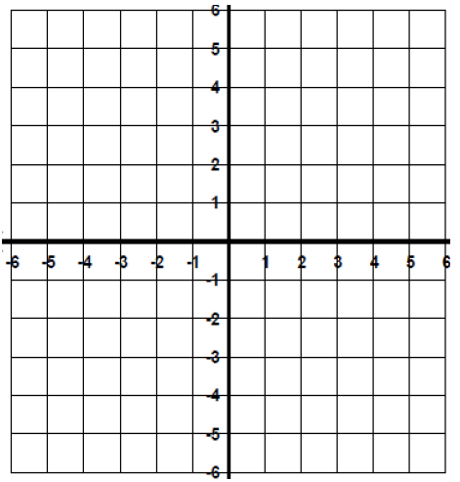 |  | Draw your own!
 |  | Draw your own!
 |  | Draw your own!
Name _____________________________________________ Domain and Range - DAY 2 NOTES |  | Draw your own!
 |  | Draw your own!

