Let’s practice finding the Domain and Range of each situation!
Name __________________________________________________Date ____/____/____
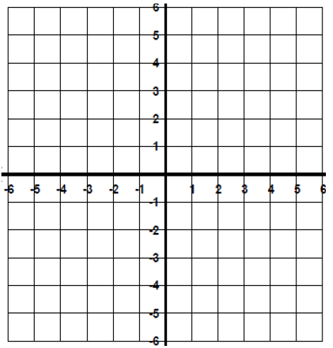
You have 3 quarts of paint to paint the trim in your house. A quart of paint covers 100 ft². The function f(x)= 100x represents the area f(x), in square in feet, that x quarts of paint cover.  Quarts Area  -1 ???  0  1  2  3 300  Domain  Range:  Continuous or Discrete | A car can travel 30 miles for each gallon of gasoline. The function ​d(x) = 30x represents the distance​ d(x), in​ miles, that the car can travel with x gallons of gasoline. The​ car's fuel tank holds 12 gal.  Gallons Miles  -1 ???  0 0  1 30  3  12 360  Domain:  Range:  Continuous or Discrete | The total height h of a stack of cans is a function of the number n of layers of 4 inch cans used. This situation is represented by h(n) =4n. (maximum of 6 cans)  # of Cans Height  -1 ???  0  1  2  3  Domain:  Range:  Continuous or Discrete
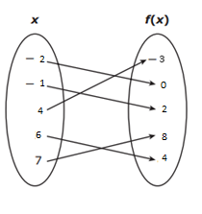 | The domain of f(x) = -1.5x + 4 is {1, 2, 3, 4}. What’s the range? | The domain of g(x) = 4x - 12 is {1, 3, 5, 7}. What is the range?
The Algebra 1 team took students with an A average on a field trip each six weeks. The number of buses needed to transport the students on each trip is a function of the number of students who were sent on each trip. This function consists of only the ordered pairs (10, 1), (55, 2), (90, 3) (170, 6), (325, 11), (500, 17).  Domain:  Range: | The total cost of renting a banquet hall is a function of the number of hours the hall is rented. The owner of the banquet hall charges $85 per hour up to a maximum of 4 hours plus a $50 cleaning fee.  Hours Cost  1  2  3  4  Domain:  (number of hours)  Range:  (Total cost) | The total cost of renting a banquet hall is a function of the number of hours the hall is rented. The owner of the banquet hall charges $85 per half hour up to a maximum of 4 hours plus a $50 cleaning fee.  Hours Cost  1  2  3  4  Domain:  (number of hours)  Range:  (Total cost)
The number of 18-wheelers, W(c), needed to transport c cars in 1 day can be found using the function W(c) = $\frac{c}{20}$ . There are no more than 6,000 cars transported by the 18-wheelers daily.  Cars 18-Wheelers | The number of boats, B(c), needed to transport c cars in 1 day can be found using the function B(c) = $\frac{c}{20}$ . There are no more than 4,000 cars transported by the boats daily.  Cars Boats

