Decide whether each scenario below is a discrete or continuous situation.
Name ______________________________________________Period _____ Date ____ / ____ / ____
Discrete and Continuous Graphs
- Temperature outside throughout the day _______________________
- The number of channels on your TV __________________________
- The model year of a car and its cost ________________________
- Students’ favorite color ______________________________
- Temperature in an oven while baking a cake _______________________
- Number of erasers you can buy with $5 ________________________
- Height of a tree over time ______________________
- Number of siblings each student has _________________________

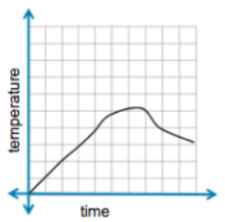
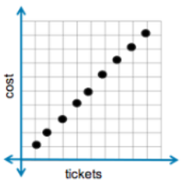
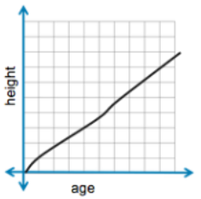
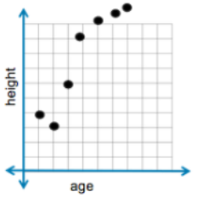
Label the graph with the correct scenario using A thru J below.

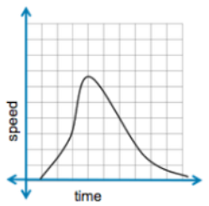
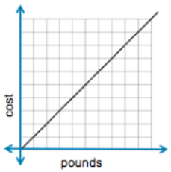

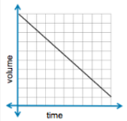
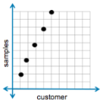

- A coach collects data on each player (age) and his height
- A gardener records the age of a tree and its height

- Tickets to a concert cost $20 each
- The temperature inside a car over time

- The market sells strawberries for $5 per pound
- The speed of a roller coaster at Disney World at various times

- The volume of the water in swimming pool steadily decreases by 15 gallons per minute
- Each customer who enters the grocery store gets 2 free samples of chocolate.

- Phillip is saving money for a dirt bike. He has $50 and saves $10 per month
- The formula F=1.8C +32 compares the temperatures in degrees Celsius, C, to temperatures in degrees Fahrenheit, F.
In this lesson you will learn to identify a function by _____________________ it’s ____________.
Name ______________________________________________Period _____ Date ____ / ____ / ____
Function Video (LZ1191 Learn Zillion)
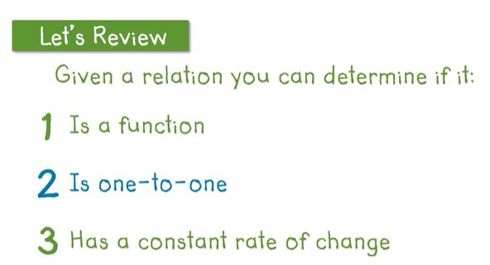

What is the common mistake below? Is the relation below a function?
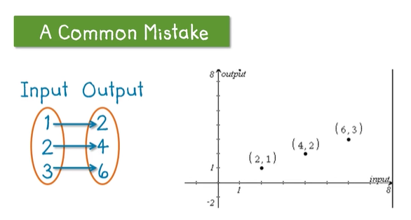
Y or N
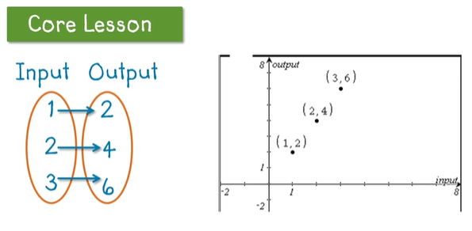
Domain Range

What is the domain and range of this graph?
D:{ } R{ }

What is the domain and range of this graph?
D:{ } R{ }

Is the relation below a function? Is the relation below a function?
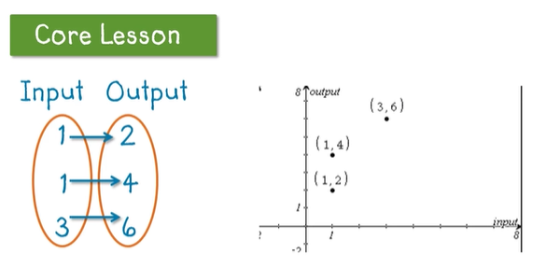
Y or N Y or N
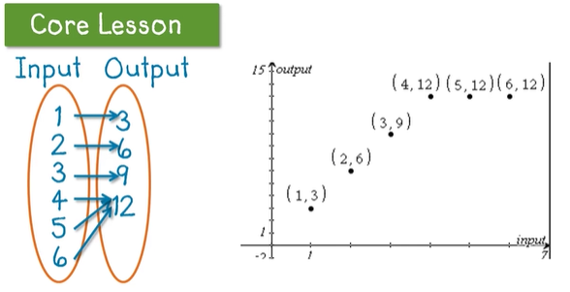
Domain Range
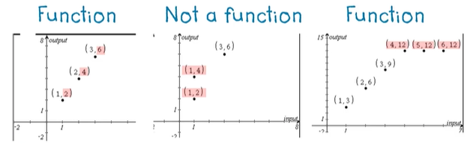
What is the domain and range of this graph?
D:{ } R{ }

What is the domain and range of this graph?
D:{ } R{ }

Why is the 2nd picture a second not a function but the other two discrete graphs are? ___________________ _________________________________________________________________________________________
