Notes: Direct Variation $y =kx$
Proportional: having the same ratio to another quantity.  Cross Multiply to see which table below is proportional.  x y  2 3  4 9  5 12  x y  2 6  4 12  5 15 | When b = 0 (graph goes through the origin), $y =mx+b$ becomes $y =kx.$  $y =2x$ $y =2$ $y =\frac{x}{3}$  m = K = ____ m = K = ____ m = K = ____  b = _____ b = _____ b = _____  Direct Variation Y or N Direct Variation Y or N Direct Variation Y or N  $x+3y=6$ m = K = ____  b = _____ Direct Variation Y or N  Direct Variation Y or N Direct Variation Y or N Direct Variation Y or N  $x =2$ m = K = ____  b = _____ Direct Variation Y or N  Direct Variation Y or N Direct Variation Y or N Direct Variation Y or N  $y =3x$ $y =-\frac{1}{2}x$ $y =3x-4$  m = K = ____ m = K = ____ m = K = ____  b = _____ b=_____ b=_____  Direct Variation Y or N Direct Variation Y or N Direct Variation Y or N
The phrase “ y varies directly with x” or “directly proportional” is used to describe direct variation problems.  At a given time, the length, L, of the shadow of an object varies directly as the height of the object, H. If the shadow is 29ft when the height of the object is 14ft, what is the length of the shadow if the height of the object is 6ft?  Height (x) Length (y)  14 29  6 ?  Y = the length  X = the height  The missing length is $\frac{6*29}{14}$ = 2.5  (cross multiply and divide) | In direct variation problems, k is:  - The same as slope, m = k  - $K = \frac{y}{x}$  - $Called the constant of variation$  Find the constant of variation, k, and write the direct variation equation.  Height (x) Length (y)  14 29  6 2.5  $K = \frac{y}{x}$ = $\frac{29}{14}= \frac{2.5}{6}=$  $y =kx= _________$
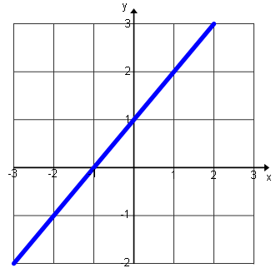
Why does this graph not represent direct variation? Why does this graph represent direct variation?
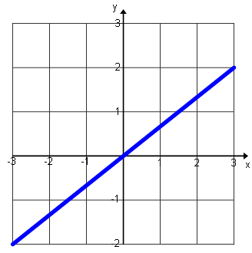

Guided Practice: Using the table, determine whether y varies directly with x.
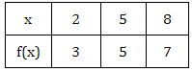  1. |  | 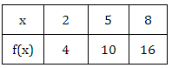  2.
3. Determine the constant of variation given a point from a direct variation situation: (6, 24) |  | 4. Determine the constant of variation given a  point from a direct variation situation: (8, -3)
Direct Variation Word Problem Practice
5. At a given time, the length, L, of the shadow of an object varies directly as the height of the object, H. If the shadow is 27ft when the height of the object is 12ft, what is the length of the shadow if the height of the object is 4ft? |  | 6. If y is directly proportional to x and y = 198 when x = 22, find y when x = 182.
7. The circumference, c, of a circle varies directly as the diameter, d. If the circumference is 44cm when the diameter is 14cm, find the diameter when the circumference is 66cm. |  | 8. If y varies directly as x and y = 80 when x = 32, find x when y = 100.
9. The perimeter, p, of an equilateral triangle is directly proportional to the length of a side, s. If the perimeter is 153cm when the side length is 51cm, what would be the perimeter if the side length is 2cm? |  | 10. Circle which represents a direct variation equation.  $$x=5 y =\frac{-2}{5}x y=3x-1$$  $$2y=-3x x+2y=14 2x+y=0$$

