Days Sold (x)  Name _________________________________________ Date ___/___/____ Period ____  Correlation coefficient and Line of best fit | Total Cost (y)
1 | 3.00
2 | 5.00
3 | 7.00
4 | 9.00
5 | 11.00
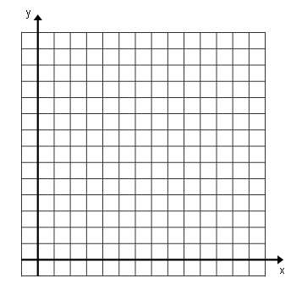
Correlation coefficient (r) : ____________
Strong /Weak Positive/Negative
Line of best fit (Linear Regression Equation y = mx+b): _________________________________________
Is there Causation? Y or N Is there Association? Y or N Why? _______________________________
Predict the total cost after selling lemonade for 10 days _________________
Using the linear regression equation, find the value of y given x=5. Why is the answer 11.00? _____________________________________________________________________________

Jolly Ranchers (x) | 2 | 5 | 8 | 10
Total Cost (y) | 5.6 | 4.7 | 3.8 | 1.9

Correlation coefficient (r) : ____________
Strong /Weak Positive/Negative
Line of best fit (Linear Regression Equation y = mx+b): ________________________________________
Is there Causation? Y or N Is there Association? Y or N Why? _______________________________
Predict the total cost for 15 bags _________________
Using the linear regression equation, find the value of y given x=2. Why is the answer not 5.6? _____________________________________________________________________________

Average Price
0 4 8 12 16 20 24 28
1.00
2.00
3.00
4.00
5.00
6.00
7.00
Years Since 1970 | Average Price
0 | 2.40
4 | 2.90
8 | 3.50
12 | 4.40
16 | 4.90
20 | 5.20
24 | 6.10
28 | 7.25

Correlation coefficient (r) : ____________
# of Years Since 1970
Strong /Weak Positive/Negative
Line of best fit (Linear Regression Equation y = mx + b): ________________________
Is there Causation? Y or N Is there Association? Y or N Why? _______________________________
Predict the average price in 2013 ____________________________
Why does x = 20 not give you y = 5.20 when using the linear regression equation (TREND LINE)? _____________________________________________________________________________________

What type of correlation does r = 0.74 represent? ___________________________
What type of correlation does r = -0.89 represent? ___________________________
What type of correlation does r = 0.23 represent? ___________________________
What type of correlation does r = 0.95 represent? ___________________________
What type of correlation does r = -0.37 represent? ___________________________
What type of correlation does r = -0.81 represent? ___________________________
What type of correlation does r =- 0.69 represent? ___________________________

START HERE WORK BACKWARDS

Graph 1 Graph 2 Graph 3
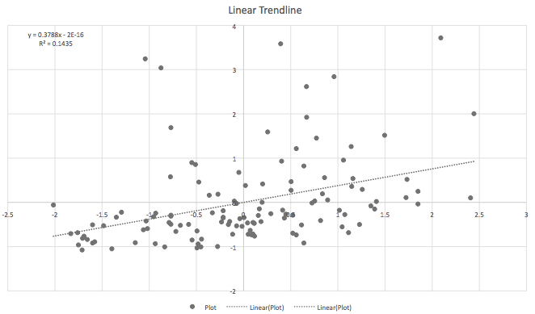
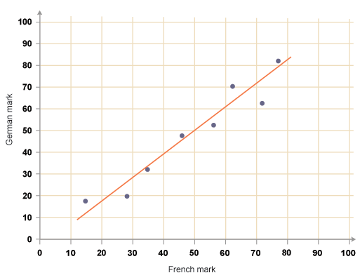
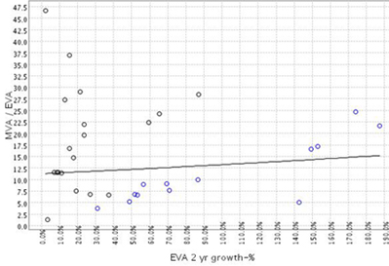

Weak / Moderate / Strong Weak / Moderate / Strong Weak / Moderate / Strong

Explain in words the purpose for identifying the correlation coefficient.
_____________________________________________________________________________________

How do you know if a correlation is likely to have causation?
_____________________________________________________________________________________

How do you know if a correlation has an association?
____________________________________________________________________________________

No correlations will likely have an association, causation, or both?
_____________________________________________________________________________________

Positive and negative correlation will likely have an association, causation, or both?
_____________________________________________________________________________________

When r = 1 you will likely have an association, causation, or both?
_____________________________________________________________________________________

