Questions:

---------------------------------------------------------------------------------------------------------------------------------------------------------------------------------------------------------------------------------------------------------------------------------------------------------------------------------------------------------------------------------------------------------------------------------------------------------------------------------------------------------------------------------------------------------------------------------------------------------------------------------------------------------------------------------------------------------------------------------------------------------------------------------------------------------------------------------------------------------------------------------------------------------------------------------

**STRONG**

**Moderate**

**Weak**

**STRONG**

**Moderate**

**Weak**

**Negative Correlation No Correlation Positive Correlation**

**Pearson Correlation Coefficient**

**-1 -0.8 -0.5 -0.2 0 0.2 0.5 0.8 1**

Name __________________________ Period _____ Date ___/___/___

Objective(s) : _________________________________________________________________________________________________________________________

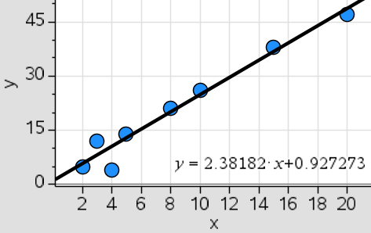

|  |  |  |  |  |  |  |  |  |
| --- | --- | --- | --- | --- | --- | --- | --- | --- |
|  | 2 | 3 | 4 | 5 | 8 | 10 | 15 | 20 |
|  | 5 | 12 | 4 | 14 | 21 | 26 | 38 | 47 |

|  |  |  |
| --- | --- | --- |
| **Verbal Description** | **Attributes of the Data** | **Table of Values and Scatterplot** |
| 1. The owner of GameStop buys and sells controllers every month. One month she bought 2 x-box controllers and sold 5 of them. Another month she bought 4 controllers and sold the 4 she bought.  # of x-box controllers bought  # of x-box controllers sold | **Relationship (circle one)**  Association or Causation  **Correlation (circle two)**  Weak Moderate Strong  Negative Positive No Correlation  **Correlation Coefficient – Measure of strength (0.980045)**  R = __________________  Trend Line (Equation of the Best Fit Line)  ____________________________ | (Label the x and y of the table and graph) |

Questions:

------------------------------------------------------------------------------------------------------------------------------------------------------------------------------------------------------------------------------------------------------------------------------------------------------------------------------------------------------------------------------------------------------------------------------------------------------------------------------------------------------------------------------------------------------------------------------------------------------------------------------------------------------------------------------------------------------------------------------------------------------------------------------------------------------------------------------------------------------------------------------------------------------------------------------------------------------------

|  |  |  |  |  |  |  |  |  |
| --- | --- | --- | --- | --- | --- | --- | --- | --- |
|  | 2 | 3 | 4 | 5 | 8 | 10 | 15 | 20 |
|  | 5 | 14 | 4 | 15 | 12 | 14 | 13 | 15 |

|  |  |  |
| --- | --- | --- |
| **Verbal Description** | **Attributes of the Data** | **Table of Values and Scatterplot** |
| 2. Angelo runs 2 miles per week and his total running distance is 5 miles. Marcos runs 4 miles per week and his total running distance is 4 miles.  Miles  Total distance | **Relationship (circle one)**  Association or Causation  **Correlation (circle two)**  Weak Moderate Strong  Negative Positive No Correlation  **Correlation Coefficient – Measure of strength (0.524774)**  R = __________________  Trend Line (Equation of the Best Fit Line)  ____________________________ | (Label the x and y of the table and graph) |
| 3. There are 2 pencils and 5 markers in the classroom supply closet. There are 4 pencils and 4 markers in another classroom supply closet.  Pencils  Markers | **Relationship (circle one)**  Association or Causation  **Correlation (circle two)**  Weak Moderate Strong  Negative Positive No Correlation  **Correlation Coefficient – Measure of strength (0.000002)**  R = __________________  Trend Line (Equation of the Best Fit Line)  ____________________________ | (Label the x and y of the table and graph) |

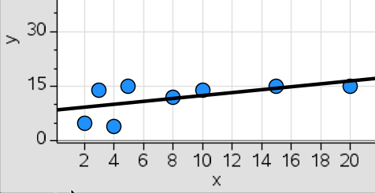

|  |  |  |  |  |  |  |  |  |
| --- | --- | --- | --- | --- | --- | --- | --- | --- |
|  | 2 | 3 | 4 | 5 | 8 | 10 | 15 | 20 |
|  | 5 | 25 | 4 | 50 | 45 | 1 | 4 | 29.355 |

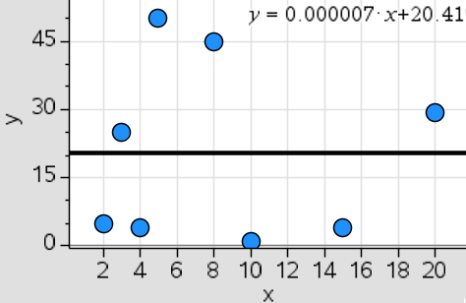

|  |  |  |  |  |  |  |
| --- | --- | --- | --- | --- | --- | --- |
|  | 1 | 4 | 6 | 7 | 10 | 11 |
|  | 50 | 43 | 36 | 35 | 20 | 15 |

Questions:

------------------------------------------------------------------------------------------------------------------------------------------------------------------------------------------------------------------------------------------------------------------------------------------------------------------------------------------------------------------------------------------------------------------------------------------------------------------------------------------------------------------------------------------------------------------------------------------------------------------------------------------------------------------------------------------------------------------------------------------------------------------------------------------------------------------------------------------------------------------------------------------------------------------------------------------------------------

|  |  |  |
| --- | --- | --- |
| **Verbal Description** | **Attributes of the Data** | **Table of Values and Scatterplot** |
| 4. The temperature in degrees on day 1 of winter was 50 degrees Fahrenheit. The temperature on day 10 was 20 degrees Fahrenheit.  Days of temperature  Temperature | **Relationship (circle one)**  Association or Causation  **Correlation (circle two)**  Weak Moderate Strong  Negative Positive No Correlation  **Correlation Coefficient – Measure of strength (-0.984437)**  R = __________________  Trend Line (Equation of the Best Fit Line)  ____________________________ | (Label the x and y of the table and graph) |
| 5. On day 1 of no sunlight the height of a plant is 50 in tall. On day 10 of no sunlight the plant is 30 in tall.  Days of sunlight  Height of the plant | **Relationship (circle one)**  Association or Causation  **Correlation (circle two)**  Weak Moderate Strong  Negative Positive No Correlation  **Correlation Coefficient – Measure of strength (-0.7560)**  R = __________________  Trend Line (Equation of the Best Fit Line)  ____________________________ | (Label the x and y of the table and graph) |

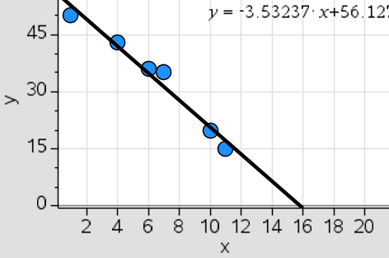

|  |  |  |  |  |  |  |  |
| --- | --- | --- | --- | --- | --- | --- | --- |
|  | 1 | 4 | 6 | 7 | 10 | 11 | 50 |
|  | 50 | 45 | 40 | 30 | 30 | 5 | 2 |

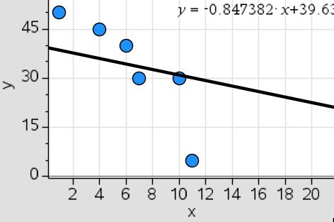

|  |  |  |  |  |  |  |  |
| --- | --- | --- | --- | --- | --- | --- | --- |
|  | 1 | 2 | 3 | 4 | 5 | 6 | 7 |
|  | 9 | 41 | 39 | 11 | 62 | 43 | 50 |

Questions:

----------------------------------------------------------------------------------------------------------------------------------------------------------------------------------------------------------------------------------------------------------------------------------------------------------------------------------------------------------------------------------------------------------------------------------------------------------------------------------------------------------------------------------------------------------------------------------------------------------------------------------------------------------------------------------------------------------------------------------------------------------------------------------------------------------------------------------------------------------------------------------------------------

|  |  |  |
| --- | --- | --- |
| **Verbal Description** | **Attributes of the Data** | **Table of Values and Scatterplot** |
| 5. Create your own example showing a positive correlation with no causation (association). | **Relationship (circle one)**  Association or Causation  **Correlation (circle two)**  Weak Moderate Strong  Negative Positive No Correlation  **Correlation Coefficient – Measure of strength (0.5900)**  R = __________________  Trend Line (Equation of the Best Fit Line)  ____________________________ | (Label the x and y of the table and graph) |
| 6. . Create your own example showing a negative correlation that has causation | **Relationship (circle one)**  Association or Causation  **Correlation (circle two)**  Weak Moderate Strong  Negative Positive No Correlation  **Correlation Coefficient – Measure of strength (-0.5900)**  R = __________________  Trend Line (Equation of the Best Fit Line)  ____________________________ | (Label the x and y of the table and graph) |

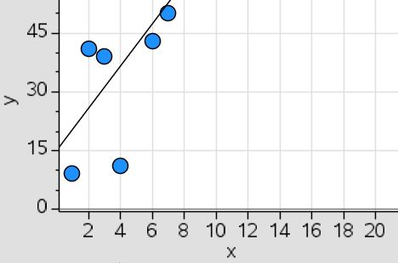

|  |  |  |  |  |  |  |  |
| --- | --- | --- | --- | --- | --- | --- | --- |
|  | 1 | 4 | 6 | 7 | 10 | 11 | 60 |
|  | 50 | 43 | 62 | 11 | 39 | 41 | 9 |

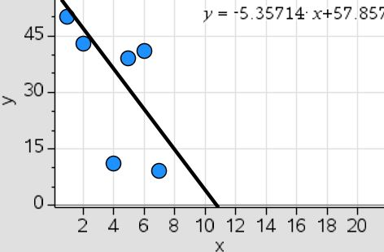

Summary : ______________________________________________________________________________________________________________________________ ______________________________________________________________________________________________________________________________________________________________________________________________________________________________________________________________________________