AR Test 5 Review Name:_______________________________ Date:_________________ Period:_________
Solve for x, graph the inequality and write your answer in words.
$$5 + 6x > -19 or 10 + 6x < -20$$  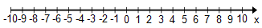  Write your answer in words: | $$3x + 6 + x > -22$$  Write your answer in words:
$$15< -5(x -2)$$  Write your answer in words: | $-16≤2\left(6x-5\right)<14$  Write your answer in words:
$$2-4\left(x +3\right)≤6$$  Write your answer in words: | $$2 – (-18x – 16) ≥ -18$$  Write your answer in words:

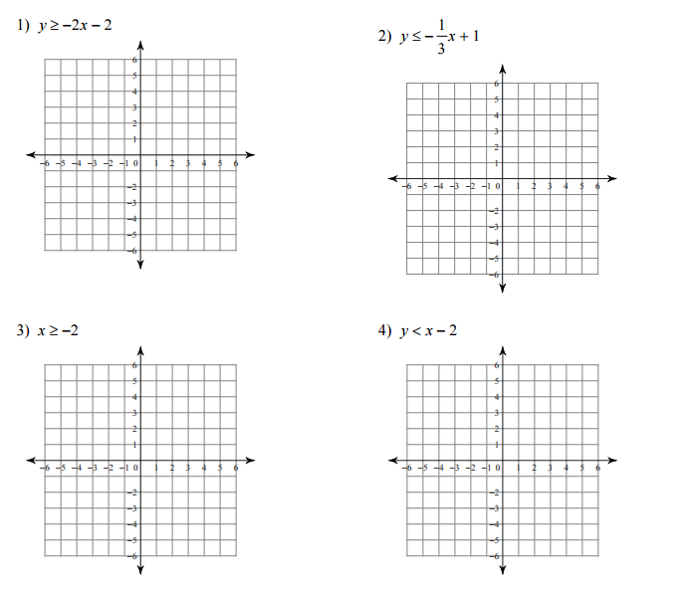
Graph the given inequality and shade appropriately.

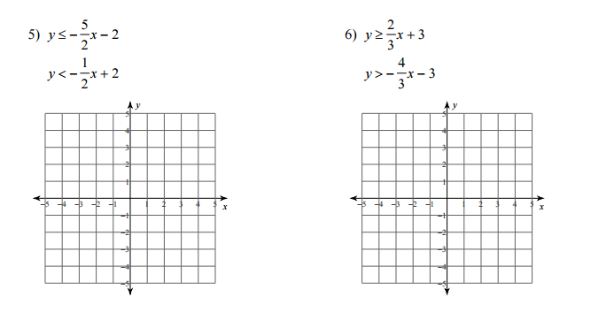
Graph the following system of inequalities and shade appropriately.

Solve the following systems by substitution.
7. x – 6y = -11 8. 4x + y = -1
3x + 2y = 7 3x – 5y = -18

Solve the following systems by elimination.
9. x + 2y = 20 10. 3x + 2y = 7
2x + y = 19 x – y = -1

Solve the following systems using a calculator.
11. 8x – 3y = -9 12. 2x – 5y = 8
5x + 4y = 12 3x + 5y = -13

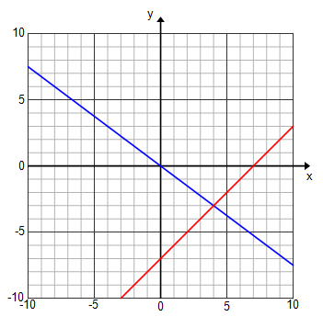
Identify the solution to the following system of equations:

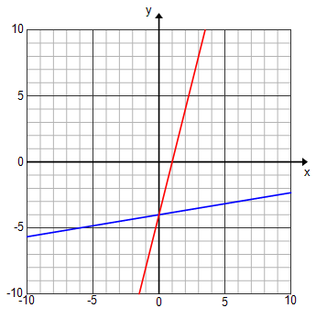
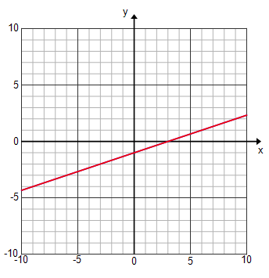
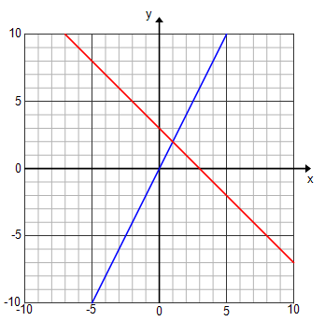

Graph the system of equations and identity the solution.
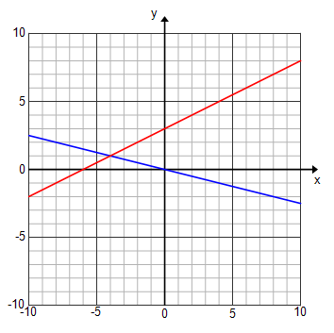
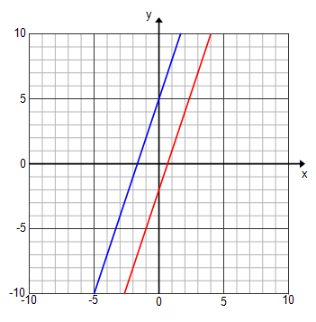
13. y = 3x – 2 14. y = x - 2
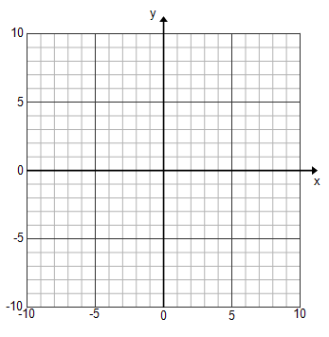
y = $\frac{1}{2}$x + 3 y = $\frac{1}{6}$x + 3

