Algebraic Reasoning TEST 3
For questions 1-4, tell whether or not the relation represents a function and explain your reasoning.
- (-4, 8), (2, -1), (5, 8), (-1, 6)

x | f(x)
-1 | 4
0 | 3
-3 | -9
3 | 5
-1 | -2

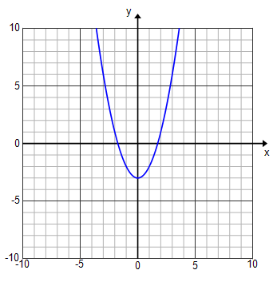

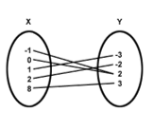

- Plot the following points on the given graph.

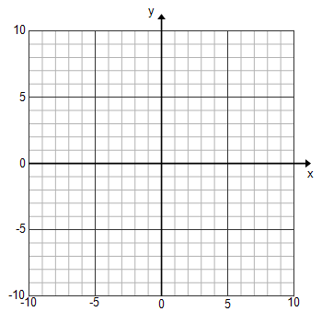
(-2, 4), (0, 5), (2, 3), (-5, -1), (6, -7)

- Calculate the slope of the line that goes through (8, -2) and (2, -2).

- Identify the slope in the following equations.
y = -3x + 5

y – 6 = 4(x – 2)

- Calculate the slope of the line given below.
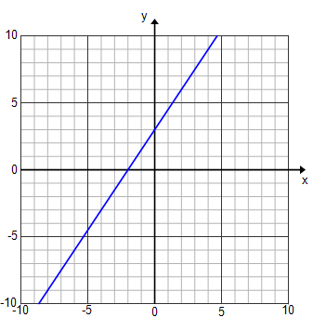

- Calculate the slope of the line given in the following table.
x |  | -4 | -2 | 0 | 2 | 4 | 6
y |  | 9 | 6 | 3 | 0 | -3 | -6

- Identify the y-intercept in the following graph.
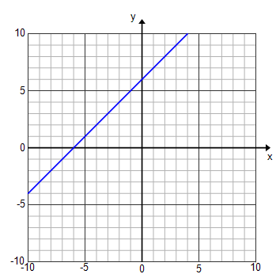

- Identify the y-intercept in the given equation.
y = 2x – 8

- Identify the y-intercept of the line represented by the given table.
x | -3 | -2 | -1 | 0
y | 3 | 6 | 9 | 12

- Identify the x-intercept of the given linear function.
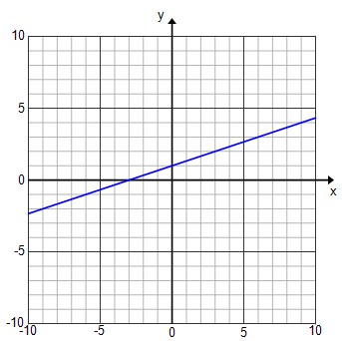

- Identify the x-intercept of the line represented by the given table.
x | -2 | -1 | 0 | 1 | 2
y | 4 | 0 | -4 | -8 | -12

For problems 15-17, write the equation of the line in slope-intercept form.
- The line with a slope of $-\frac{5}{3}$ that goes through the point (0, -10).

x | y
-3 | -8
0 | -4
3 | 0
6 | 4

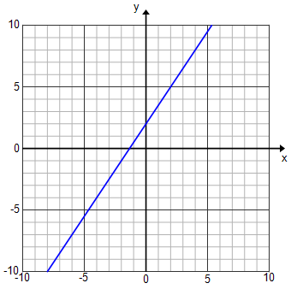

For problems 18-20, write the equation of the given line in point-slope form.

x | -4 | -1 | 0 | 2 | 5
f(x) | 10 | 4 | 2 | -2 | -8

- The line with a slope of -5 that goes through the point (3, -3).

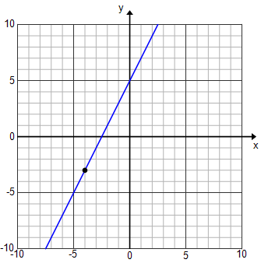

- The line that goes through (8, 3) and (-1, -3).

For problems 22-23, put the equations for the linear functions in slope-intercept form.
- y – 9 = –2(x – 4)

- 4x – 10y = 3

- Identify the slope in the following equation.
–3x – 2y = 5

