Algebra 1 Unit 1 TEST REVIEW

Use the scenario and table below to answer questions 1, 2, and 3

A teacher collected data for two different quizzes. The table of values below show the relationship between the number of points scored on Quiz 1 and the number of points scored on Quiz 2.

|  |  |
| --- | --- |
| Quiz 1 | Quiz 2 |
| 30 | 25 |
| 35 | 25 |
| 55 | 65 |
| 65 | 60 |
| 80 | 85 |
| 95 | 85 |

1. (A.4A) Calculate the correlation coefficient between the points scored on the two quizzes. Answer this question using the number grid. Round to the nearest hundredth (2 decimal places).
2. (A.4C) Find the best fit line that describes the relationship between the number of points on Quiz 1 and the number of points scored on Quiz 2.
3. (A.4A) Identify the type of correlation.

Weak or Strong Positive or Negative

1. (A.4A and A.4B) The table shows the altitude of an airplane and the temperature outside a plane.

|  |  |  |  |  |  |  |  |
| --- | --- | --- | --- | --- | --- | --- | --- |
| Altitude (meters) | 1000 | 2000 | 3000 | 4000 | 5000 | 6000 | 7000 |
| Temperature (Celsius) | 12.5 | 5.25 | 2 | -3.25 | -7.5 | -10.75 | -14 |

Which words most accurately describe the correlation and causation for the data set?

Strong or weak? Positive or negative? Causation likely or causation unlikely?

5. (A.4A and A.4B) The scatterplot shows the relationship between effects of global warming and ants on an anthill.

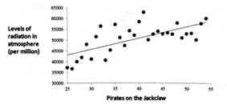

Ants counted on an Anthill

Levels of radiation in the atmosphere (per million)

Which words accurately describe the correlation and causation for the data set? Strong or weak…..positive or negative

Causation likely or unlikely

1. (A.12A) Which graph does not represent y as a function of x?

A.                                              B.                                           C.                                                  D.                  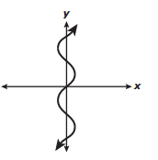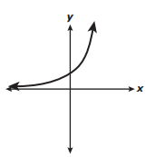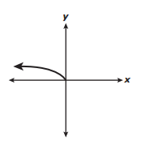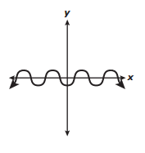

7. (A.12B) The domain of f(x) = -4.1x + 2 is {1, 2, 3, 4}. What is the range?

8. (A.12B) The range of f(x) = 5x is {0, 5, 10, 15}. What is the domain?

9. (A.12A) The function f(x) = {(1,3), (2, 6), (3, 9), (4, 12)} can be represented in several other ways. Which is not a correct representation of the function f(x)?

* 1. y = 3x where x is a natural number.
  2. x is a natural number and  y is 3 times x.

C.                                                                  D.           yD.

3

6

9

12

1

2

3

4

10. (A.12A) Which representations do not show y as a function of x?

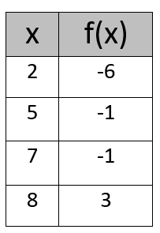          {(-1, -2), (0, 1), (-1, 4), (7, 7)}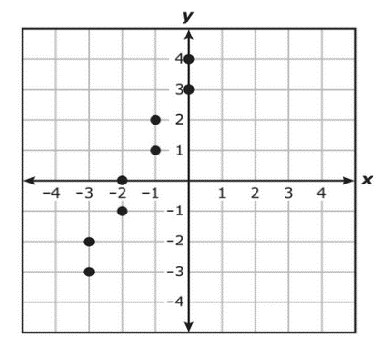  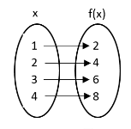

11. (A.4A and A.4C) Find the correlation coefficient and the best fit line of the given data.

|  |  |
| --- | --- |
| Age, x | Mean Earnings, y |
| 20 | 51 |
| 25 | 55 |
| 30 | 70 |
| 35 | 43 |
| 40 | 60 |
| 45 | 45 |
| 50 | 20 |
| 55 | 65 |

12. (A.4A) Find the correlation coefficient of the data below.    Record your answer with the number grid. Round to the nearest hundredth (2 decimal

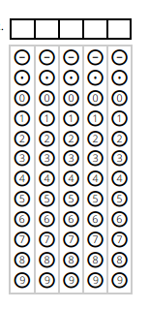

|  |  |  |  |  |
| --- | --- | --- | --- | --- |
| m&ms | 3 | 5 | 9 | 11 |
| Total cost | 5.3 | 4.8 | 6.2 | 9 |

places).

13. (A.12A) Which situation below represents the graphed relationship? 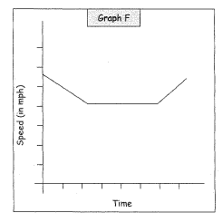

A. A school bus going 30mph approaches a school zone, slows to 20mph, then speeds back up as it leaves the school zone.

B. A school bus slows to a stop and loads a student then accelerates back to its speed

14.   (A.2A)   Which representations of a function below have the correct .domain and range listed underneath them?

|  |  |  |  |
| --- | --- | --- | --- |
| https://lh5.googleusercontent.com/tL7p_OJKdFKFR7M845DvOZjhS4NVZ16kjzgLnPEahh1npU2erZYVayyfBGrv4xWvvMvL8f16p6HId9iMc27V14ZmgIIZg8ESKbp7dIrTBg8yjLTaj7o_iA3PP5RnbgQYU3bSBRzk | https://lh3.googleusercontent.com/W_EShAjSUWsdkuu55P0nCTg67EblQj4iRHN5RGe88HnUeYwbjq6G2zU5Gzvi5mAxLl2gpfoV3dhRS-uY37unPVSQ_2fo1xlmem-FshBdaMMvZlnW03HFaqRq1t89m-tzoo-hb2RL | https://lh4.googleusercontent.com/-yA5jCPRZO3nWYGqMHtAg9ee96z4Gk2VmqKmw-yB4N78Bt1x0ZLvfqfiiPwqwvyka3BldgE332Ulg5pU03Qtf--v7gMiV-G_eJZjwTqhmvzzUtzswQ2FmEZjB6oaIyPNWI1TVnnt | The total height, h, of a stack of cans is a function of the number of layers of 4 inch cans used.  This situation is represented by h(n) = 4n.  (maximum of 6 cans) |
| 1. D:    x -        R:     y0 | II.    D:  x =1             R:   y < 2 | III.  D  -5 x<0           R:  -2<y4 | IV.   D: { 1, 2, 3, 4, 5, 6}        R: { 4, 8, 12, 16, 20, 24} |

1. I and II B. I, II, and III C.  II, and IV D.  I, II, III, and IV

15.(A.12A) Which below is a true statement?

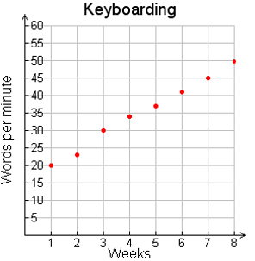

1. The number of words typed per week is constant
2. The graph should be connected
3. The graph should not be connected
4. The graph is not a function

16. (A.2A) Identify the domain and range of the function represented by the graph.

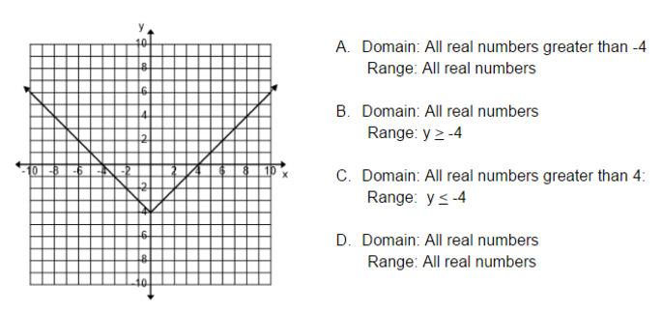  
  
  
17. (A.4C)

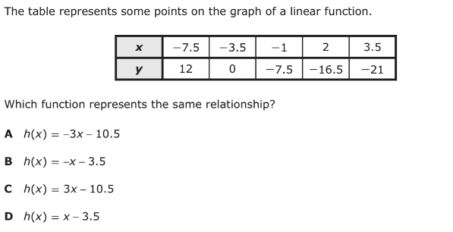

18. (A.4C) The scatterplot shows the monthly high temperatures for Austin, Texas, in degrees Fahrenheit

over a 12-month period.

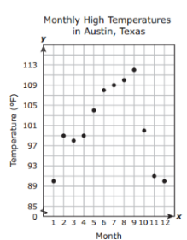

Write a function that best models the data from Month 5 to Month 8