Algebra 1 UNIT 2 TEST REVIEW

1. Driving a Truck

What is the slope of the line in this graph?

What is the rate of change? What does it represent?

What does the x-intercept represent?

What does the y-intercept represent?

Fuel Remaining in Tank in Gallons

0 2 4 6 8 10 12 14 16 18 20 22

250

200

150

100

50

Time in Hours



1. Which table shows the same rate of change as the equation $y = 5 -\frac{3}{8} x$?

|  |  |
| --- | --- |
| x | y |
| -2 | 6 |
| 0 | 5 |
| 4 | 3 |
| 6 | 2 |

|  |  |
| --- | --- |
| x | y |
| -3 | 0 |
| -1 | 2 |
| 0 | 3 |
| 4 | 7 |

|  |  |
| --- | --- |
| x | y |
| -8 | 8 |
| 0 | 5 |
| 4 | 3.5 |
| 8 | 2 |

|  |  |
| --- | --- |
| x | y |
| -3 | -14 |
| -1 | -8 |
| 1 | -2 |
| 3 | 4 |

1. Your friend needs to lose weight to wrestle in a certain weight class. His goal is to lose 3 pounds per week. After 3 weeks, his weight is down to 125 pounds. What represents the slope of this loss?



1. Where is the zero of this function?  
     
     
   Between _____ and ______.
2. A company purchases a forklift to help with loading items for shipping. The graph shows the value of the forlift over a period of time.



How much time has passed? ________

$ 25000

$ 20000

15000

10000

5000

What was the purchase price? _______

Is the forklift increasing or decreasing in value?

What is the rate of change of this value? _________

Can you write the equation for this function?

___________________________________

At what age will it have no value? _______

0 1 2 3 4 5 6 7 8 9 10 11

Age in Years of Forklift

What was its value at 5 years old? ___________

|  |  |
| --- | --- |
| Playing time, x  (Min) | File size, y  (MB) |
| 0.5 | 80 |
| 1.5 | 240 |
| 2 | 320 |
| 4 | 640 |
| 4.5 | 720 |

1. The table shows the playing time in minutes of some online videos and the file size of these videos in megabytes (MB).

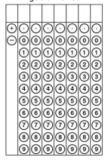

What is the slope of this function and what does it represent?

Record the rate of change in the grid in.

1. The function y = 6 + 1.25x can be used to find the cost of joining an online movie club and buying x movies from the website. Based on this information, which statement about the graph of this situation is true?

A The y-intercept of the graph represents the cost of each movie.

B The y-intercept of the graph represents the cost of joining the movie club.

C The slope of the graph represents the total number of movies bought by members of the club.

D The slope of the graph represents the number of movies each member buys when visiting the website.

1. Record the zero of this linear function on the grid in.







Which statements are true about the graph provided?

1. x-intercept: ( 0, 4)
2. Y-intercept: ( 0, -4)
3. Zero: ( 5, 0)
4. Slope: $\frac{4}{5}$

The graph shows the altitude of a plane as it starts its descent for landing.

What is the y-intercept and what does it represent? _______________________

What was the starting altitude for the landing pattern? __________

What is the x-intercept and what does it represent? _______________________

How many minutes will pass until the plane is on the ground? ____________

What is the slope and what does it represent? _______________________

What is the rate of descent? _________





2500

2000

1500

1000

500

Altitude in feet

0 1 2 3 4 5 6 7 8 9 10 11

Time of descent in minutes

1. The graph shows the relationship between the number of keychains a presenter at a convention had left to give away and the number of presentations she had made.

What does the y-intercept represent?____________

How many keychains were there before the presentations started? ________________

What is the slope and what does it represent? ___________________________________________

Will the presenter have enough keychains to do the 8th presentation at the rate she is giving them away?

What is the x-intercept? What does it represent?



Number of Keychains

0 1 2 3 4 5 6 7 8 9 10 11

Number of Presentations

100

80

60

40

20

1. A teacher collected data for two different quizzes. The scatterplot below shows the relationship between the number of points scored o Quiz 1 and the number of points scored on Quiz 2.

|  |  |
| --- | --- |
| Quiz 1 | Quiz 2 |
| 40 | 20 |
| 60 | 55 |
| 70 | 80 |
| 90 | 95 |
| 95 | 95 |
| 100 | 100 |



Calculate the correlation coefficient between the points scored on the two quizzes. Round to the nearest tenth (two decimal places). Answer this question using the number grid

Which of these values COULD be the correlation value of this graph? Which could not?

1. – 0.45
2. 0.98
3. 0.75
4. 0.85
5. – 0.85

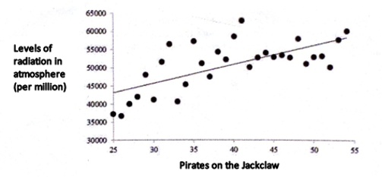

1. Garrett has 8 bracelets made to sell at the craft fair. After working 4 hours, he has a total of 16 bracelets made to sell at the craft fair.

If x represents the amount of time spent making bracelets and y represents the number of bracelets made, which below represents the y-intercept?

1. 8 B. 16 C. 5 D. 4

If x represents the amount of time spent making bracelets and y represents the number of bracelets made, which below represents the change in y over the change in x?

1. 3 B. 11 C. 5 D. 2



1. Identify the slope of **y + 4 = -2(x – 6)** and answer using the number grid.

Anita does the same number of sit-ups each day over a period of several days. On the 6th day, she has completed a total of 360 sit-ups. By the 8th day, she has completed a total of 520. What value equals the slope of the line of the total number of sit-ups when graphed against the day? Answer using the number grid.



2. Which below is not a linear function?

I. II. $y =\frac{1}{x}$ III. IV. The total cost of a t-shirt

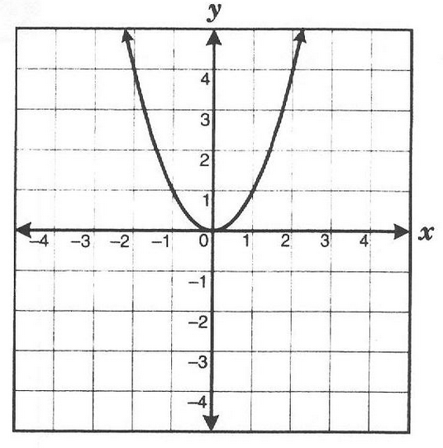

|  |  |
| --- | --- |
| x | y |
| 1 | -7 |
| 4 | 2 |
| 7 | 11 |
| 10 | 20 |

1. The temperature at sunrise is 40 degrees Fahrenheit. Each hour, the temperature rises 5 degrees. The “y” represents the temperature, in degrees Fahrenheit, after “x” hours. Graph this function.



What is the slope? _____________

What is the y-intercept? ___________

What is represented by the Domain? _______

What does the range represent? _________

1. Each time a truck stops, it drops off 200 pounds of cargo. It started with a load of 3000 pounds. Write the nth term and determine how much the load weighs after the 5th stop.
2. Find the explicit formula for the nth term for the arithmetic sequence below. What is the value of a25 ?

72, 79, 86, 93

1. The first five terms in a pattern are shown below.

3.5, 4.0, 4.5, 5.0, 5.5… $\frac{7}{2}, 4, \frac{9}{2}, 5, \frac{11}{2}$…

If the pattern continues, write the expression that can be used to find the nth term.

1. A car can travel 25 miles for each gallon of gasoline. The function ​d(x) = 25x represents the distance​ d(x), in​ miles, that the car can travel with x gallons of gasoline. The​ car's fuel tank holds 12 gallons. What is the domain for this situation?
2. Isolate the variable: $-3(x-1) = ½(6 – 8x)$